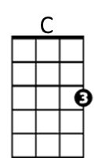**Lola (Ray Davies)**

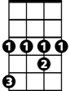

Ab



Bb

**Intro: Ab Bb C**

**C**

I met her in a club down in old Soho

**F Bb**

Where you drink champagne and it tastes just like

**C F Fsus4 F**

coca cola - C-O-L-A, c ola

**C**

She walked up to me and she asked me to dance

**F Bb**

I asked her her name and in a dark brown voice

**C**

She said “Lola”

**F Bb Ab Bb C**

L-O-L-A, Lola, Lo lo lo lo lola

**C**

Well I'm not the world’s most physical guy

**F**

but when she squeezed me tight

**Bb C**

she nearly broke my spine, oh my Lola

**F Fsus4 F**

Lo lo lo lo Lola

**C**

Well I'm not dumb but I can't understand

**F Bb**

why she walked like a woman and talked like a man

**C**

oh my Lola

**F Bb Ab Bb C**

Lo lo lo lo Lola Lo lo lo lo Lola

**G7**

Well we drank champagne and danced all night

**D**

under electric candlelight

**F**

She picked me up and sat me on her knee

and said 'Dear boy, won't you come home with me'

**C**

Well I'm not the world's most passionate guy

**F**

But when I looked in her eye,

**Bb C**

Well I almost fell for my Lola

**F Bb Ab Ab Bb**

Lo lo lo lo Lola Lo lo lo lo Lola

**C F Bb Ab Ab Bb C**

Lola, Lo lo lo lo Lola, lo lo lo lo Lola

**F C G7**

I pushed her away

**F C G7**

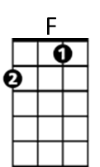I walked to the door

**F C G7**

I fell to the floor

**C Em Am**

I got down on my knees

**G7**

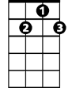

G7

Then I looked at her and she at me

**C**

Well that's the way that I want it to stay

**F Bb C**

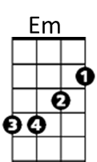and I always want it to be that way for my Lola

**F Fsus4 F**

Lo lo lo lo Lola

**C**

Girls will be boys and boys will be girls

**F Bb**

It's a mixed up, muddled up, shook up world except

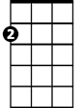

Am

**C F**

for Lola - Lo lo lo lo Lola

**G7**

Well I left home just a week before

**D**

And I'd never ever kissed a woman before

**F**

Lola smiled and took me by the hand

and said 'Dear boy, I'm gonna make you a man'

**C**

Well I'm not the world’s most passionate man

**F Bb**

But I know what I am and what I am is a man

**C F Bb Ab Ab Bb**

and so is Lola, lo lo lo lo lola Lo lo lo lo Lola

**(3X – end C)**

**C F Bb Ab Ab Bb**

Lola, lo lo lo lo Lola, lo lo lo lo Lola

**BARITONE**

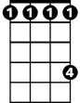

Ab

C

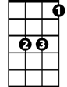

Bb



F

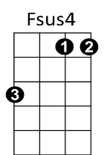



Em

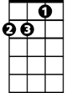

Am

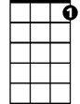

G7

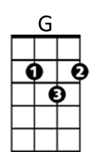**Lola (Ray Davies)**

**Intro: Eb F G**

**G**

I met her in a club down in old Soho

**C F**

Where you drink champagne and it tastes just like

**G**

coca cola

**C Csus4 C**

C-O-L-A, cola

**G**

She walked up to me and she asked me to dance

**C F**

I asked her her name and in a dark brown voice she

**G**

said “Lola”

**C F Eb F G**

L-O-L-A, Lola, Lo lo lo lo lola

**G**

Well I'm not the world’s most physical guy

**C**

but when she squeezed me tight

**F G**

she nearly broke my spine, oh my Lola

**C Csus4 C**

Lo lo lo lo Lola

**G**

Well I'm not dumb but I can't understand

**C F**

why she walked like a woman and talked like a man

**G**

oh my Lola

**C F Eb F G**

Lo lo lo lo Lola Lo lo lo lo Lola

**D7**

Well we drank champagne and danced all night

**A**

under electric candlelight

**C**

She picked me up and sat me on her knee

and said 'Dear boy, won't you come home with me'

**G**

Well I'm not the world's most passionate guy

**C**

But when I looked in her eye,

**F G**

Well I almost fell for my Lola

**C F Eb Eb F**

Lo lo lo lo Lola Lo lo lo lo Lola

**G C F Eb Eb F G**

Lola, Lo lo lo lo Lola, lo lo lo lo Lola

**C G D7**

I pushed her away

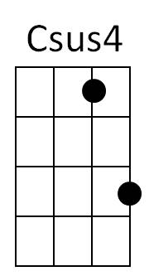 **C G D7**

I walked to the door

**C G D7**

I fell to the floor

**G Bm Em**

I got down on my knees

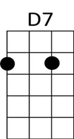 **D7**

Then I looked at her and she at me

**G**

Well that's the way that I want it to stay

** C F G**

and I always want it to be that way for my Lola

**C Csus4 C**

Lo lo lo lo Lola

**G**

Girls will be boys and boys will be girls

**C F**

It's a mixed up, muddled up, shook up world except

**G C**

for Lola- Lo lo lo lo Lola

**D7**

Well I left home just a week before

**A**

And I'd never ever kissed a woman before

**C**

Lola smiled and took me by the hand

and said 'dear boy, I'm gonna make you a man'

**G**

Well I'm not the world’s most passionate man

**C F**

But I know what I am and what I am is a man

**G C F Eb Eb F**

and so is Lola, lo lo lo lo lola Lo lo lo lo Lola

**G C F Eb Eb F (3x, end G)**

Lola, lo lo lo lo Lola, lo lo lo lo Lola

**BARITONE**



G



F

C



D7



Eb

Bm

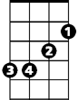

Em