Lollypop (Julius Dixson and Beverly Ross, 1958) (A)
Lollypop by The Chordettes (1958) (Bb – 143 BPM)
Lollypop by Bobby Vee (1958) (A - 137 BPM)

Intro A F#m | Bm7 E7 |  Chorus  A F#m Bm7 E7 A F#m Bm7 E7  Lollipop, Lollipop, oh, Lolli, Lolli, Lolli. Lollipop, Lollipop, oh, Lolli, Lolli, Lolli.  A F#m Bm7 E7  Lollipop, Lollipop, oh, Lolli, Lolli, Lolli.  A | E7 |  LOLLIPOP!. Ba, boomp, boomp, boomp!  Repeat Chorus  A D A D A F#m7 Bm7 E7  Call my baby Lollipop, tell you why. __ His kiss is sweeter than an apple pie.  A D A D  __ And when he does his shaky rockin' dance,  E7 Tacet A E7  Man, I haven't got a chance, I call him Chorus  Bridge  D A D A  Sweeter than candy on a stick, Huckleberry, Cherry or Lime.  D B7 E7  If you had a choice, he'd be your pick, but Lollipop is mine, oh Chorus  A D A D A F#m7 Bm7 E7  Crazy way he thrills me, tell you why. __ Just like a lightning from the sky.  A D A D E7 Tacet A E7  __ He loves to kiss me, till I can't see straight. Gee, my Lollipop is great. I call him  Outro  A F#m Bm7 E7 A F#m Bm7 E7  Lollipop, Lollipop, oh, Lolli, Lolli, Lolli. Lollipop, Lollipop, oh, Lolli, Lolli, Lolli.  A F#m Bm7 E7 A E7 - A  Lollipop, Lollipop, oh, Lolli, Lolli, Lolli. LOLLIPOP!. |  |  |  |  |  |  |  |  | 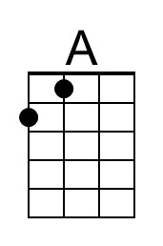
 |  |  |  |  |  |  |  |  | 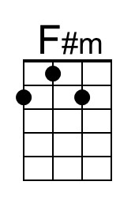
 |  |  |  |  |  |  |  |  | 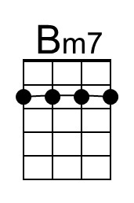
 |  |  |  |  |  |  |  |  | 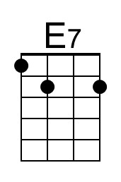
 |  |  |  |  |  |  |  |  | 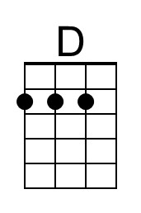
 |  |  |  |  |  |  |  |  | 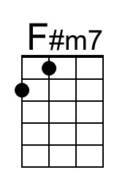
 |  |  |  |  |  |  |  |  | 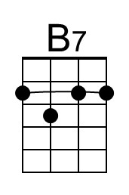
Bari | 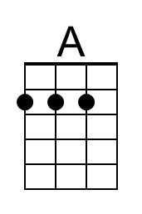 | 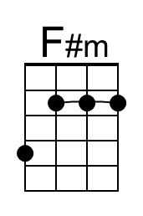 | 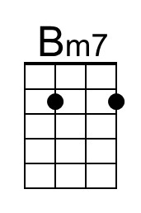 | 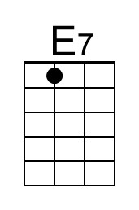 | 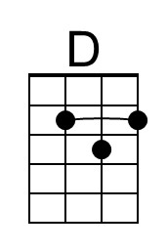 | 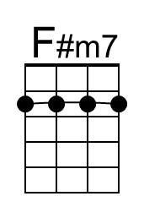 | 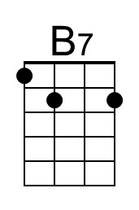

Lollypop (Julius Dixson and Beverly Ross, 1958) (C)
Lollypop by The Chordettes (1958) (Bb – 143 BPM)
Lollypop by Bobby Vee (1958) (A - 137 BPM)

Intro C Am | Dm7 G7 |  Chorus  C Am Dm7 G7 C Am Dm7 G7  Lollipop, Lollipop, oh, Lolli, Lolli, Lolli. Lollipop, Lollipop, oh, Lolli, Lolli, Lolli.  C Am Dm7 G7 C | G7 |  Lollipop, Lollipop, oh, Lolli, Lolli, Lolli. LOLLIPOP!. Ba, boomp, boomp, boomp!  Repeat Chorus  C F C F C Am7 Dm7 G7  Call my baby Lollipop, tell you why. __ His kiss is sweeter than an apple pie.  C F C F  __ And when he does his shaky rockin' dance,  G7 Tacet C G7  Ma, I haven't got a chance… I call him Chorus  Bridge  F C F C  Sweeter than candy on a stick, Huckleberry, Cherry or Lime.  F D7 G7  If you had a choice, he'd be your pick, but Lollipop is mine, oh Chorus  C F C F C Am7 Dm7 G7  Crazy way he thrills me, tell you why. __ Just like a lightning from the sky.  C F C F G7 Tacet C G7  __ He loves to kiss me, till I can't see straight. Gee, my Lollipop is great. I call him  Outro  C Am Dm7 G7 C Am Dm7 G7  Lollipop, Lollipop, oh, Lolli, Lolli, Lolli. Lollipop, Lollipop, oh, Lolli, Lolli, Lolli.  C Am Dm7 G7 C G7 - C  Lollipop, Lollipop, oh, Lolli, Lolli, Lolli. LOLLIPOP!. |  |  |  |  |  |  |  |  | 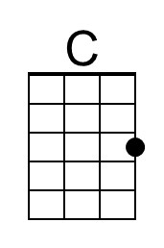
 |  |  |  |  |  |  |  |  | 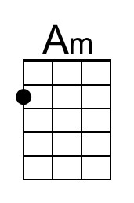
 |  |  |  |  |  |  |  |  | 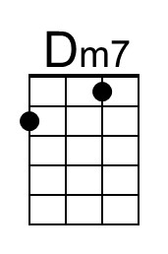
 |  |  |  |  |  |  |  |  | 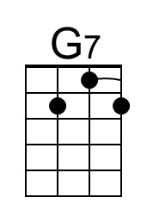
 |  |  |  |  |  |  |  |  | 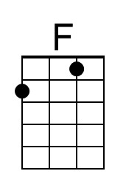
 |  |  |  |  |  |  |  |  | 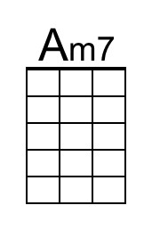
Bari | 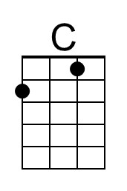 | 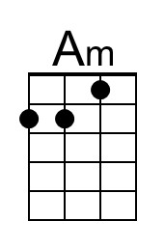 | 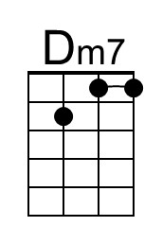 | 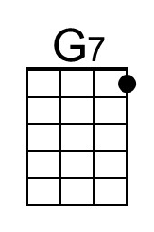 | 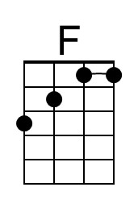 | 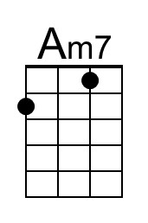 | 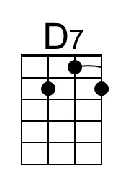 |  | 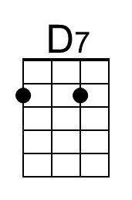

Lollypop (Julius Dixson and Beverly Ross, 1958) (G)
Lollypop by The Chordettes (1958) (Bb – 143 BPM)
Lollypop by Bobby Vee (1958) (A - 137 BPM)

Intro G Em | Am7 D7 |  Chorus  G Em Am7 D7 G Em Am7 D7  Lollipop, Lollipop, oh, Lolli, Lolli, Lolli. Lollipop, Lollipop, oh, Lolli, Lolli, Lolli.  G Em Am7 D7 G | D7 |  Lollipop, Lollipop, oh, Lolli, Lolli, Lolli. LOLLIPOP!. Ba, boomp, boomp, boomp!  Repeat Chorus  G C G C G Em7 Am7 D7  Call my baby Lollipop, tell you why. __ His kiss is sweeter than an apple pie.  G C G C  __ And when he does his shaky rockin' dance,  D7 Tacet G D7  Man, I haven't got a chance… I call him Chorus  Bridge  C G C G  Sweeter than candy on a stick, Huckleberry, Cherry or Lime.  C A7 D7  If you had a choice, he'd be your pick, but Lollipop is mine, oh Chorus  G C G C G Em7 Am7 D7  Crazy way he thrills me, tell you why. __ Just like a lightning from the sky.  G C G C D7 Tacet G D7  __ He loves to kiss me, till I can't see straight. Gee, my Lollipop is great. I call him  Outro  G Em Am7 D7 G Em Am7 D7  Lollipop, Lollipop, oh, Lolli, Lolli, Lolli. Lollipop, Lollipop, oh, Lolli, Lolli, Lolli.  G Em Am7 D7 G D7 - G  Lollipop, Lollipop, oh, Lolli, Lolli, Lolli. LOLLIPOP!. |  |  |  |  |  |  |  |  | 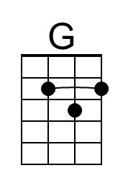
 |  |  |  |  |  |  |  |  | 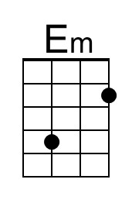
 |  |  |  |  |  |  |  |  | 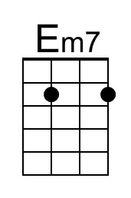
Bari | 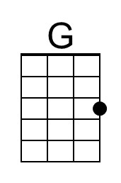 | 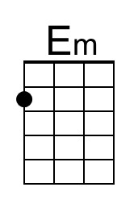 |  |  |  | 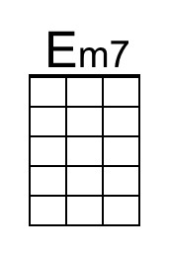 | 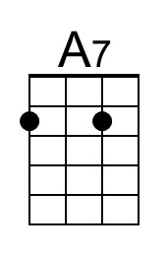 |  | 