Lonely People (Dan Peek & Catherine Peek) (C)

Intro: C Am Em C Am Em F G C Am F G C G  C Am Em  This is for all the lonely people,  C Am Em  Thinking that life has passed them by  F G C Am  Don't give up until you drink from the silver cup,  F G C G  And ride that highway in the sky  C Am Em  This is for all the single people,  C Am Em  Thinking that love has left them dry  F G C Am  Don't give up until you drink from the silver cup,  F G C G  You never know until you try  F C Dm  Well, I'm on my way  F C Dm  Yes, I'm back to stay  F C Dm G C G  Well, I'm on my way back home (Hit it)  C Am Em C Am Em F G C Am F G C G  C Am Em  This is for all the lonely people,  C Am Em  Thinking that life has passed them by  F G C Am  Don't give up until you drink from the silver cup,  F G C Am  She’ll never take you down, or never give you up,  F G Am  You never know until you try. |  |  |  |  |  |  | 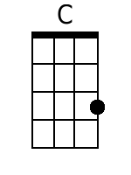
 |  |  |  |  |  |  | 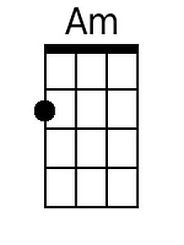
 |  |  |  |  |  |  | 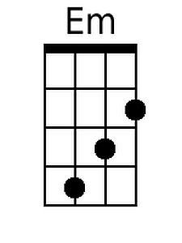
 |  |  |  |  |  |  | 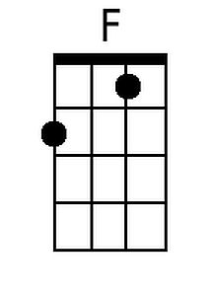
 |  |  |  |  |  |  | 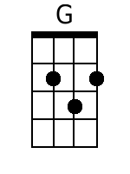
Bari
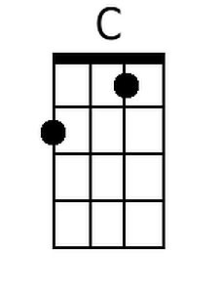 | 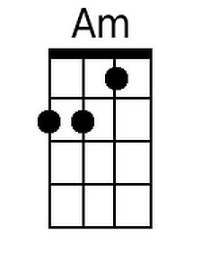 | 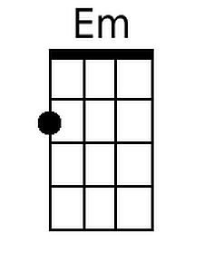 | 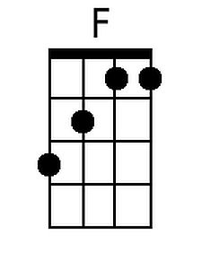 | 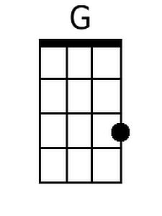

Lonely People (Dan Peek & Catherine Peek) (G)

Intro: G Em Bm G Em Bm C D G Em C D G D

G Em Bm
This is for all the lonely people,
G Em Bm
Thinking that life has passed them by
C D G Em
Don't give up until you drink from the silver cup,
C D G D
And ride that highway in the sky

G Em Bm
This is for all the single people,
G Em Bm
Thinking that love has left them dry
C D G Em
Don't give up until you drink from the silver cup,
C D G D
You never know until you try

C G Am
Well, I'm on my way
C G Am
Yes, I'm back to stay
C G Am D G D
Well, I'm on my way back home (Hit it)

G Em Bm G Em Bm C D G Em C D G D

G Em Bm
This is for all the lonely people,
G Em Bm
Thinking that life has passed them by
C D G Em
Don't give up until you drink from the silver cup,
C D G Em
She'll never take you down, or never give you up,
C D Em
You never know until you try.

 |  |  |  |  |  |  | 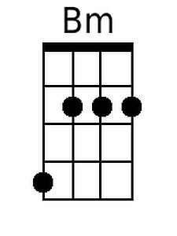
 |  |  |  |  |  |  | 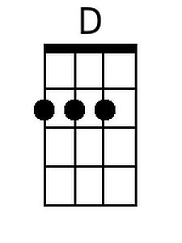
Bari
 |  | 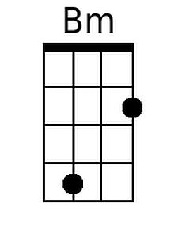 |  | 