**Lonely People (Dan Peek)**

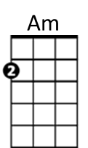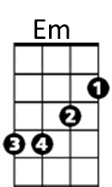**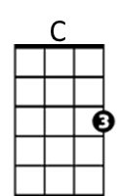Intro: C Am Em C Am Em F G C Am F G C G**

**C Am Em**

This is for all the lonely people,

**C Am Em**

Thinking that life has passed them by

**F G C Am**

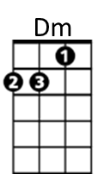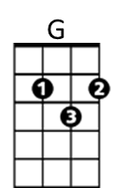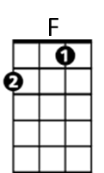Don't give up until you drink from the silver cup,

**F G C G**

And ride that highway in the sky

**C Am Em**

This is for all the single people,

**C Am Em**

Thinking that love has left them dry

**F G C Am**

Don't give up until you drink from the silver cup,

**F G C G**

You never know until you try

**F C Dm**

Well, I'm on my way

**F C Dm**

Yes, I'm back to stay

**F C Dm G C G**

Well, I'm on my way back home (Hit it)

**C Am Em C Am Em F G C Am F G C G**

**C Am Em**

This is for all the lonely people,

**C Am Em**

Thinking that life has passed them by

**F G C Am**

Don't give up until you drink from the silver cup,

**F G C Am**

She’ll never take you down, or never give you up,

**F G Am**

You never know until you try