**Long, Long Time (Gary White)**



G

F

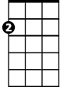

Am

**F G Am F G C**

Love will abide. Take things in stride.

**F G7 Am D7 G**

Sounds like good advice, but there's no one at my side;

**F G Am F G C**

And time washes clean love's wounds unseen;

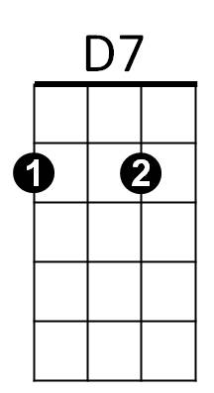 **F G7 Am D7 G7**

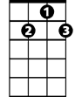

G7



C

That's what someone told me, but I don't know what it means.

**F G7 C Am F**

‘Cause I've done everything I know to try and make you mine,

**C G Am F C G C**

And I think I'm gonna love you for a long, long tim e.

**F G Am F G C**

Caught in my fears, blinking back the tears;

**F G7 Am D7 G**

I can't say you hurt me when you never let me near.

**F G Am F G C**

And I never drew one response from you,

**BARITONE**

**F G7 Am D7 G7**

All the while you fell over girls you never knew.



F

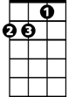

Am



G

**F G7 C Am F**

‘Cause I've done everything I know to try and make you mine,

**C G Am F C G C**

And I think I'm gonna love you for a long, long time.



D7

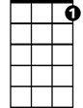

G7

C



**F G Am F G C**

Wait for the day ~ you go away,

**F G7 Am D7 G**

Knowing that you warned me of the price I'd have to pay;

**F G Am F G C**

And life's full of loss, who knows the cost,

**F G7 Am D7 G7**

Living in the mem - o - ry of the love that never was.

**F G7 C Am F**

Cause I've done everything I know to try and change your mind,

**C G Am F G C**

And I think I'm gonna miss you for a long, long time.

**F G C C7 F Am**

'Cause I've done everything I know to try and make you mine,

**C G Am F C G C**

And I think I'm gonna love you for a long, long time.