Look What They’ve Done To My Song (Melanie Safka) (C)

Intro: C  C Am  Look what they've do ne to my song, Ma  F  Look what they've done to my song  C D  It was the only thing that I could do half right  F  And now it's turning out all wrong, Ma  C G C  Look what they've done to my song  C Am  Look what they've done to my brain, Ma  F  Look what they've done to my brain  C D  Well they've picked it like a chicken bone  F  I think I'm half insane, Ma  C G C  Look what they've done to my brain  C Am  I wish I could find a good book to live in  F  I wish I could find a good book  C D  'Cause if I could find a real good book  F  Then I'd never have to come out and look at  C G C  What they've done to my song. |  |  | C Am  But maybe it'll all be alright, Ma  F  Maybe it'll all be okay  C D  'Cause if people are buying tears  F  Maybe I'll be rich one day, Ma  C G C  Maybe it'll all be okay  C Am  Look what they've done to my song, Ma  F  Look what they've done to my song  C D  Well they tied it up in a plastic bag  F  And turned it upside down, Oh, my ma  C G C  Look what they've done to my song. |  |  | 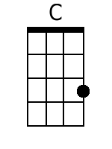
 |  |  |  |  |  | 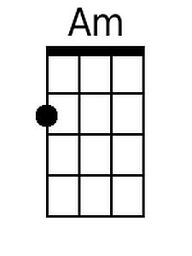
 |  |  |  |  |  | 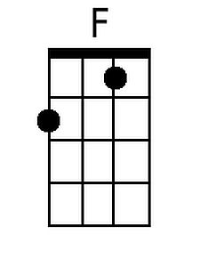
 |  |  |  |  |  | 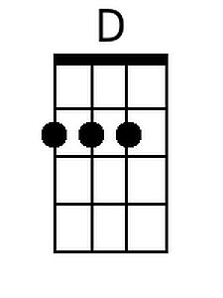
 |  |  |  |  |  | 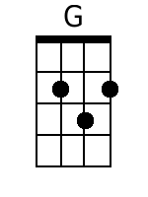
Bari
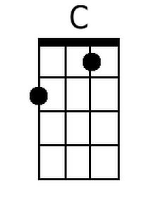 | 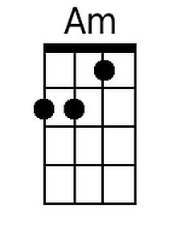 | 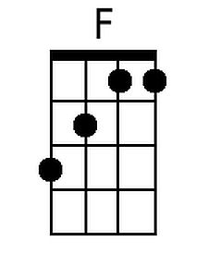 | 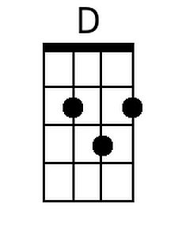 | 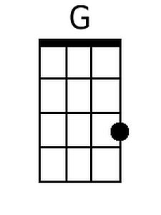

Look What They’ve Done To My Song (Melanie Safka) (G)

Intro: G  G Em  Look what they've do ne to my song, Ma  C  Look what they've done to my song  G A  It was the only thing that I could do half right  C  And now it's turning out all wrong, Ma  G D G  Look what they've done to my song  G Em  Look what they've done to my brain, Ma  C  Look what they've done to my brain  G A  Well they've picked it like a chicken bone  C  I think I'm half insane, Ma  G D G  Look what they've done to my brain  G Em  I wish I could find a good book to live in  C  I wish I could find a good book  G A  'Cause if I could find a real good book  C  Then I'd never have to come out and look at  G D G  What they've done to my song |  |  | G Em  But maybe it'll all be alright, Ma  C  Maybe it'll all be okay  G A  'Cause if people are buying tears  C  Maybe I'll be rich one day, Ma  G D G  Maybe it'll all be okay  G Em  Look what they've done to my song, Ma  C  Look what they've done to my song  G A  Well they tied it up in a plastic bag  C  And turned it upside down, Oh, my ma  G D G  Look what they've done to my song.
 |  |  |  |  |  | 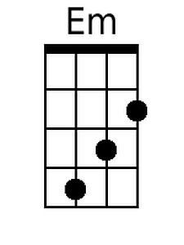
 |  |  |  |  |  | 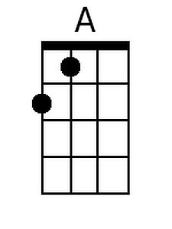
Bari
 | 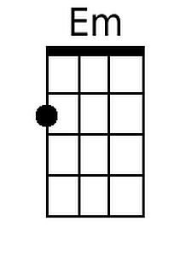 |  | 