Love Hurts (Boudleaux Bryant, 1960) (C)
Love Hurts by The Everly Brothers (F# - 91 BPM) (1960, 2007 Remaster)
Love Hurts by Roy Orbison (Bb - 84 BPM) (1961)
Love Hurts by Nazareth (G - 80 BPM) (1974)

Intro (4 Measures) C | C Bb | C | C Bb  C Am F G7  Love hurts, love scars, love wounds and mars  C Am F G7  Any heart not tough nor strong e-nough  C E7 Am  To take a lot of pain, take a lot of pain.  C F Dm G7  Love is like a cloud, pulls a lot of rain.  Chorus  C Bb F C - G7  Love hurts. mmm mmm. Love hurts.  C Am F G7  I'm young, I know, but even so  C Am F G7  I know a thing or two I learned from you.  C E7 Am  I really learned a lot, really learned a lot.  C F Dm G7  Love is like a stove burns you when it's hot. Chorus  Bridge  F E7 Am E7 Am E7 Am  Some fools dream of happi-ness, blissful-ness, together-ness  D7 F G7  Some fools fool themselves I guess, but they're not fooling me.  C Am  I know it isn't true, know it isn't true.  F G7  Love is just a lie, made to make you blue. Chorus (2x) |  |  |  |  |  |  |  | 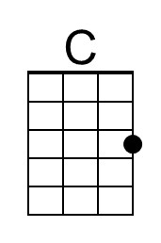
 |  |  |  |  |  |  |  | 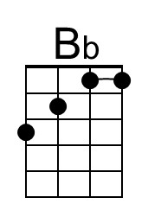
 |  |  |  |  |  |  |  | 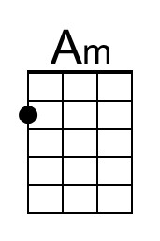
 |  |  |  |  |  |  |  | 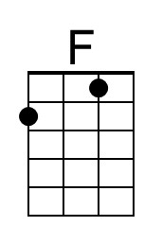
 |  |  |  |  |  |  |  | 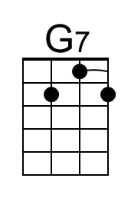
 |  |  |  |  |  |  |  | 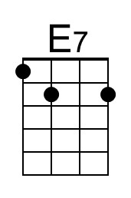
 |  |  |  |  |  |  |  | 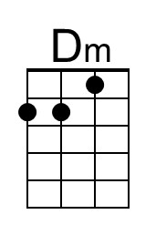
Bari | 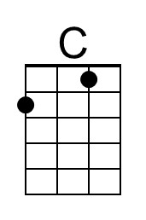 | 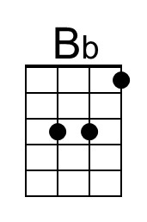 | 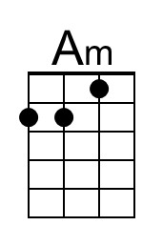 | 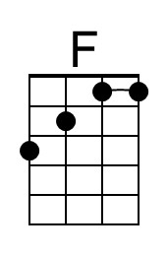 | 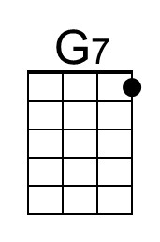 | 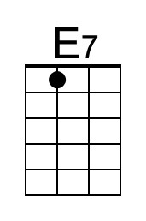 | 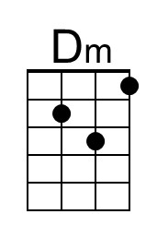

Love Hurts (Boudleaux Bryant, 1960) (F)
Love Hurts by The Everly Brothers (F# - 91 BPM) (1960, 2007 Remaster)
Love Hurts by Roy Orbison (Bb - 84 BPM) (1961)
Love Hurts by Nazareth (G - 80 BPM) (1974)

Intro (4 Measures) F | F Eb | F | F Eb

F Dm Bb C7
Love hurts, love scars, love wounds and mars
F Dm Bb C7
Any heart not tough nor strong e-nough
F A7 Dm
To take a lot of pain, take a lot of pain.
F Bb Gm C7
Love is like a cloud, pulls a lot of rain.

Chorus
F Eb Bb F - C7
Love hurts. mmm mmm. Love hurts.

F Dm Bb C7
I'm young, I know, but even so
F Dm Bb C7
I know a thing or two I learned from you.
F A7 Dm
I really learned a lot, really learned a lot.
F Bb Gm C7
Love is like a stove burns you when it's hot. Chorus

Bridge
Bb A7 Dm A7 Dm A7 Dm
Some fools dream of happi-ness, blissful-ness together-ness
G7 Bb C7
Some fools fool themselves I guess, but they're not fooling me.

F Dm
I know it isn't true, know it isn't true.
Bb C7
Love is just a lie, made to make you blue. Chorus (2x)

 |  |  |  |  |  |  |  | 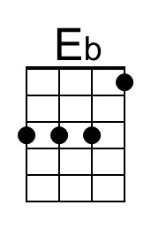
 |  |  |  |  |  |  |  | 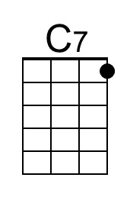
 |  |  |  |  |  |  |  | 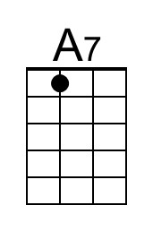
 |  |  |  |  |  |  |  | 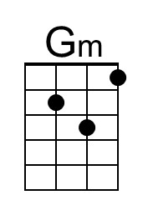
Bari |  | 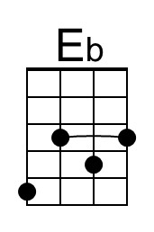 |  |  | 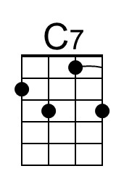 | 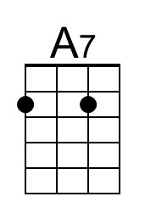 | 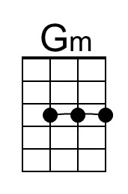

Love Hurts (Boudleaux Bryant, 1960) (G)
Love Hurts by The Everly Brothers (F# - 91 BPM) (1960, 2007 Remaster)
Love Hurts by Roy Orbison (Bb - 84 BPM) (1961)
Love Hurts by Nazareth (G - 80 BPM) (1974)

Intro (4 Measures) G | G F | G | G F  G Em C D7  Love hurts, love scars, love wounds and mars  G Em C D7  Any heart not tough nor strong e-nough  G B7 Em  To take a lot of pain, take a lot of pain.  G C Am D7  Love is like a cloud, pulls a lot of rain.  Chorus  G F C G - D7  Love hurts. mmm mmm. Love hurts.  G Em C D7  I'm young, I know, but even so  G Em C D7  I know a thing or two I learned from you.  G B7 Em  I really learned a lot, really learned a lot.  G C Am D7  Love is like a stove burns you when it's hot. Chorus  Bridge  C B7 Em B7 Em B7 Em  Some fools dream of happi-ness, blissful-ness together-ness  A7 C D7  Some fools fool themselves I guess, but they're not fooling me.  G Em  I know it isn't true, know it isn't true.  C D7  Love is just a lie, made to make you blue. Chorus (2x) |  |  |  |  |  |  |  | 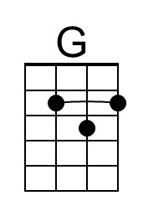
 |  |  |  |  |  |  |  | 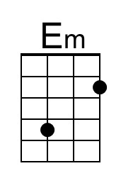
 |  |  |  |  |  |  |  | 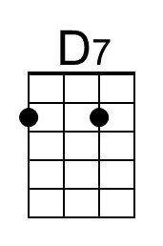
 |  |  |  |  |  |  |  | 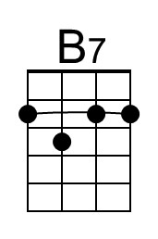
Bari | 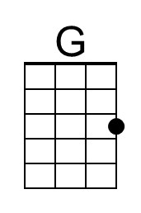 |  | 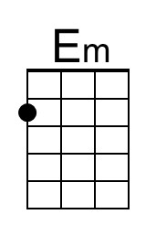 |  | 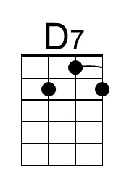 | 