Love Potion No. 9 (Jerry Leiber & Mike Stoller, 1959) (Am)
Love Potion No. 9 by the Searchers (1964)

Am ↓↓ D7  I took my troubles down to Madam Ruth,  Am ↓↓ D7  You know, that gypsy with the gold-capped tooth.  C  She's got a pad down on 34th and Vine,  D7 E7↓ Am | D7 E7 |  Sellin' little bottles of __ Love Potion Number Nine.  Am D7 Am D7  I told her that I was a flop with chicks; I've been that way since 19-56.  C  She looked at my palm and she made a magic sign  D7 E7↓ Am  She said, "What you need is __ Love Potion Number Nine.”  Chorus  D7  She bent down and turned around and gave me a wink  Bm  She said, "I'm gonna make it up right here in the sink"  D7  It smelled like turpentine and looked like Indian ink  E7↓ E7↓↓  I held my nose, I closed my eyes, ___ I took a drink.  Am D7 Am D7  I didn't know if it was day or night. I started kissin' ev'ry thing in sight.  C  But when I kissed a cop down on 34th and Vine,  D7 E7↓ Am | D7 E7 |  He broke my little bottle of ___ Love Potion Number Nine.  Second time: Am then to Outro  Repeat from Chorus.  Outro:  E7 Am  Love Potion Number Nine (3x. Retard last time through) |  |  |  |  |  |  | 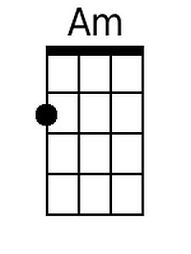
 |  |  |  |  |  |  | 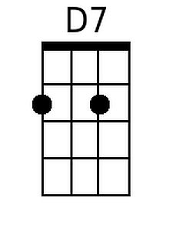
 |  |  |  |  |  |  | 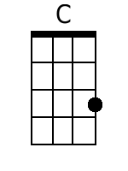
 |  |  |  |  |  |  | 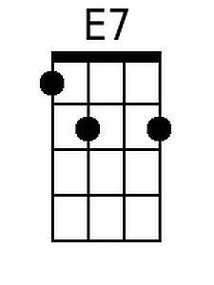
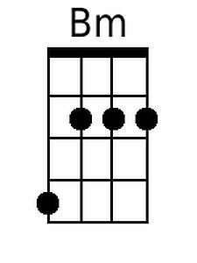
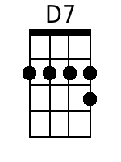
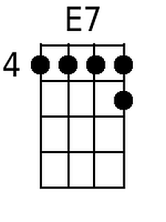

Baritone
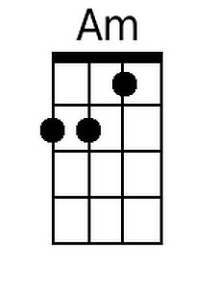 | 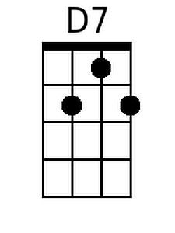 | 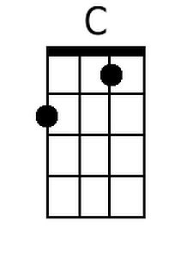 | 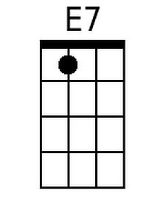 | 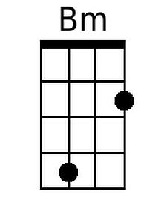

Love Potion No. 9 (Jerry Leiber & Mike Stoller, 1959) (Dm)
Love Potion No. 9 by the Searchers (1964)

Dm ↓↓ G7  I took my troubles down to Madam Ruth,  Dm↓↓ G7  You know, that gypsy with the gold-capped tooth.  F  She's got a pad down on 34th and Vine,  G7 A7↓ Dm | G7 A7 |  Sellin' little bottles of __ Love Potion Number Nine.  Dm G7 Dm G7  I told her that I was a flop with chicks; I've been that way since 19-56.  F  She looked at my palm and she made a magic sign  G7 A7↓ Dm  She said, "What you need is __ Love Potion Number Nine."  Chorus  G7  She bent down and turned around and gave me a wink  Em  She said, "I'm gonna make it up right here in the sink"  G7  It smelled like turpentine and looked like Indian ink  A7↓ A7↓↓  I held my nose, I closed my eyes, ___ I took a drink.  Dm G7 Dm G7  I didn't know if it was day or night. I started kissin' ev'ry thing in sight.  F  But when I kissed a cop down on 34th and Vine,  G7 A7↓ Dm | G7 A7 |  He broke my little bottle of ___ Love Potion Number Nine.  Second time: Dm then to Outro  Repeat from Chorus.  Outro:  A7 Dm  Love Potion Number Nine (3x. Retard last time through) |  |  |  |  |  |  | 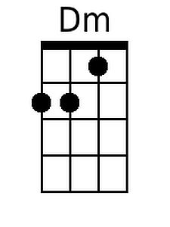
 |  |  |  |  |  |  | 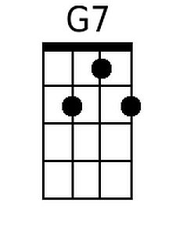
 |  |  |  |  |  |  | 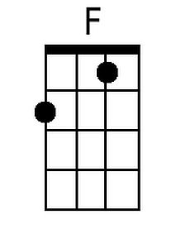
 |  |  |  |  |  |  | 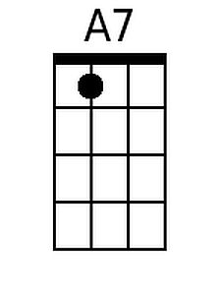
 |  |  |  |  |  |  | 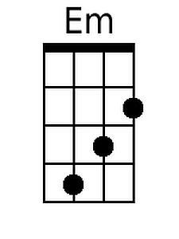
Baritone
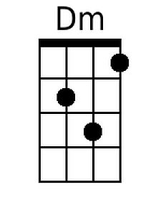 | 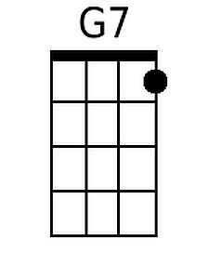 | 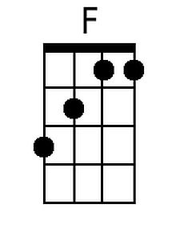 | 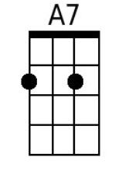 | 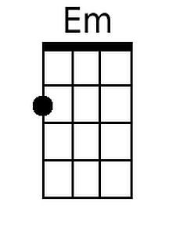

Love Potion No. 9 (Jerry Leiber & Mike Stoller, 1959) (Em)
Love Potion No. 9 by the Searchers (1964)

Em↓↓ A7
I took my troubles down to Madam Ruth,
Em↓↓ A7
You know, that gypsy with the gold-capped tooth.
G
She's got a pad down on 34th and Vine,
A7 B7↓ Em | A7 B7 |
Sellin' little bottles of __ Love Potion Number Nine.

Em A7 Em A7
I told her that I was a flop with chicks; I've been that way since 19-56.
G
She looked at my palm and she made a magic sign
A7 B7↓ Em
She said, "What you need is __ Love Potion Number Nine."

Chorus
A7
She bent down and turned around and gave me a wink
F#m
She said, "I'm gonna make it up right here in the sink"
A7
It smelled like turpentine and looked like Indian ink
B7↓ B7↓↓
I held my nose, I closed my eyes, ___ I took a drink.

Em A7 Em A7
I didn't know if it was day or night. I started kissin' ev'ry thing in sight.
G
But when I kissed a cop down on 34th and Vine,
A7 B7↓ Em | A7 B7 |
He broke my little bottle of ___ Love Potion Number Nine.
Second time: Em then to Outro
Repeat from Chorus.

Outro:
B7 Em
Love Potion Number Nine (3x. Retard last time through)

 |  |  |  |  |  |  | 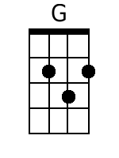
 |  |  |  |  |  |  | 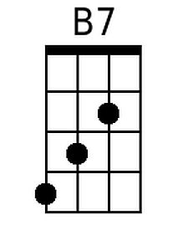
 |  |  |  |  |  |  | 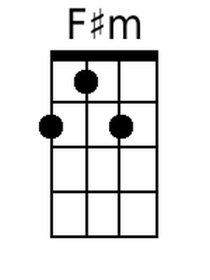
Baritone
 |  | 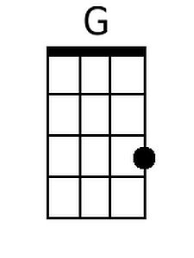 | 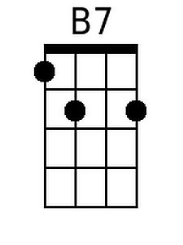 | 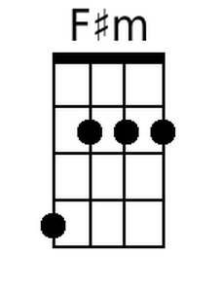 | 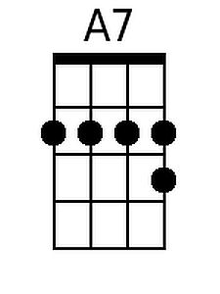 | 