**Love Potion Number 9 (Jerry Leiber / Mike Stoller) (The Clovers)**

**Am Dm**

I took my troubles down to Madame Ruth.

**Am Dm**

You know that Gypsy with the gold-capped tooth.

**C Am F**

She's got a pad down on Thirty-Fourth and Vine,

**Dm E7 Am E7**

Sellin' little bottles of Love Potion Number Nine

**Am Dm**

I told her that I was a flop with chicks.

**Am Dm**

I've been this way since nineteen-fifty-six.

**C**

She looked at my palm

**Am F**

and she made a magic sign..

**Dm**

She said, 'What you need is,

**E7 Am**

Love Potion Number Nine.'

**CHORUS:**

**Dm**

She bent down and turned around and gave me a wink.

**B7**

She said "I'm gonna mix it up right here in the sink."

**Dm**

It smelled like turpentine, it looked like India Ink..

**E7**

I held my nose, I closed my eyes, I took a drink.

**Am Dm**

I didn't know if it was day or night.

**Am Dm**

I started kissin' everything in sight.

**C**

But when I kissed a cop

**Am F**

Down on Thirty-Fourth and Vine,

**Dm**

He broke my little bottle of -

**E7 Am**

Love Potion Number Nine.

**(CHORUS)**

**Am Dm**

I didn't know if it was day or night.

**Am Dm**

I started kissin' everything in sight.

**C Am F**

I had so much fun that I'm goin' back again..

**Dm**

I wonder what happens with,

**E7 Am**

Love Potion Number Ten?

**Dm Am**

Love Potion Number Nine...

**Dm Am**

Love Potion Number Nine.

**Dm TACET Am G Am**

Love Potion Number Ni. .i.. i.. i.. ine.

**BARITONE**

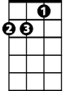

Am

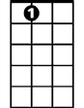

E7

B7

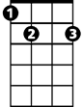

C

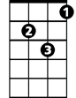

Dm



F

F



C



Dm

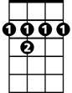

B7

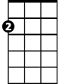

Am

E7

