**Love Potion Number Nine (Jerry Leiber / Mike Stoller) (The Clovers)**

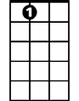

A7

F

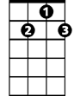

G7

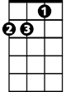

Dm

**Dm G7**

I took my troubles down to Madame Ruth

**Dm G7**

You know that gypsy with the gold-capped tooth

**F Dm**

She's got a pad down on Thirty-Fourth and Vine

**G7 A7 Dm A7**

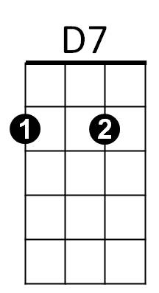Sellin' little bottles of ~ Love Potion Number Nine

E7

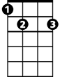

G

**Dm G7**

I told her that I was a flop with chicks

**Dm G7**

I'd been this way since 1956

**F Dm**

She looked at my palm and she made a magic sign

**G7 A7 Dm D7**

She said, "What you need is Love Potion Number Nine"

**G**

She bent down and turned around and gave me a wink

**E7**

She said, "I'm gonna make it up right here in the sink"

**G**

It smelled like turpentine, it looked like India ink

**BARITONE**

**A7**



F

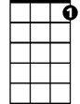

G7

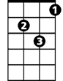

Dm

I held my nose, I closed my eyes, I took a drink

**Dm G7**

I didn't know if it was day or night

**Dm G7**

I started kissin' everything in sight

**F Dm**

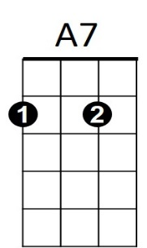But when I kissed a cop down on Thirty-Fourth and Vine



G



D7

**G7 A7 Dm A7**

He broke my little bottle of Love Potion Number Nine

**(Instrumental chorus) G / E7 / G**

**A7**

I held my nose, I closed my eyes, I took a drink



E7

**Dm G7**

I didn't know if it was day or night

**Dm G7**

I started kissin' everything in sight

**F Dm**

I had so much fun that I’m going back again

**G7 A7 Dm**

I wonder what happens with - Love Potion Number Ten

**A7 Dm** **A7 Dm A7 Dm**

Love Potion Number Ni – ne, Love Potion Number Ni – ne, Love Potion Number Ni - ne