
Love Will Keep Us Alive (C)
(Pete Vale, Jim Capaldi & Paul Carrack, late 80s-early 90s)
Love Will Keep Us Alive by The Eagles (1994) (A)
4/4 Time – Tempo 90 BPM

Intro (8 measures) | C | C | Am | Am | F | F | G | G  C Am | Am  I was standin' all alone against the world outside.  F G | G7  You were searchin' for a place to hide.  C Am | Am  Lost and lonely, now you've given me the will to survive.  F G C | C  When we're hungry, love will keep us a-live.  C Am | Am  Don't you worry sometimes you've just gotta let it ride.  F G | G7  The world is changin' right before your eyes.  C Am | Am  Now I've found you, there's no more empti-ness inside.  F G C | C7  When we're hungry, love will keep us a-live.  Chorus  F | F | Am | Am  I would die for you, __ climb the highest mountain.  Dm | Dm | G | G7  Baby, there's nothin' I wouldn't do. |  |  |  |  |  |  | 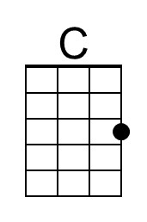 | 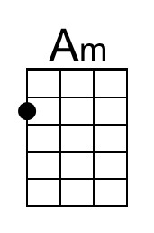
 |  |  |  |  |  |  | 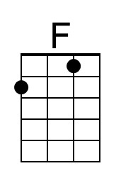 | 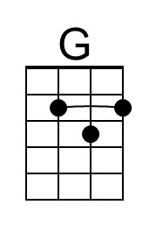
 |  |  |  |  |  |  | 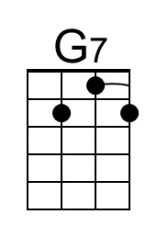 | 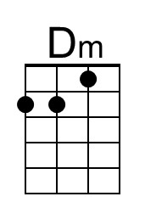
 |  |  |  |  |  |  | 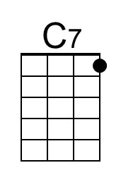
Bari | 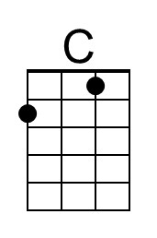 | 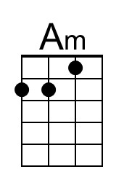 | 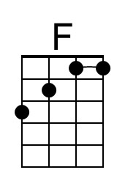 | 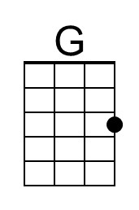 | 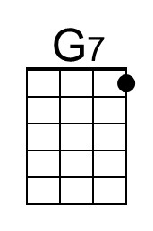 | 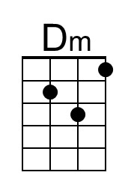
Love Will Keep Us Alive (C) – Page 2

C Am | Am
Now I've found you, there's no more empti-ness inside.
F G C | C
When we're hungry, love will keep us a-live.
Instrumental
C Am | Am
Now I've found you, there's no more empti-ness inside.
F G C | C7
When we're hungry, love will keep us a-live.

Chorus
F | F | Am | Am
I would die for you, __ climb the highest mountain.
Dm | Dm | G | G7
Baby, there's nothin' I wouldn't do.

C Am | Am
I was standin' all alone against the world outside.
F G | G7
You were searchin' for a place to hide.
C Am | Am
Lost and lonely, now you've given me the will to survive.
F G C | C7
When we're hungry, love will keep us a-live

Outro
F G C | Am
When we're hungry, love will keep us a-live.
F G C | C | C | C
When we're hungry, love will keep us a-live.
Love Will Keep Us Alive (A)
(Pete Vale, Jim Capaldi & Paul Carrack, late 80s-early 90s)
Love Will Keep Us Alive by The Eagles (1994) (A)
4/4 Time – Tempo 90 BPM

Intro (8 measures) A A F#m F#m D D E E  A F#m | F#m  I was standin' all alone against the world outside.  D E E7  You were searchin' for a place to hide.  A F#m | F#m  Lost and lonely, now you've given me the will to survive.  D E A A  When we're hungry, love will keep us a-live.  A F#m | F#m  Don't you worry sometimes you've just gotta let it ride.  D E E7  The world is changin' right before your eyes.  A F#m | F#m  Now I've found you, there's no more empti-ness inside.  D E A A7  When we're hungry, love will keep us a-live.  Chorus  D D F#m | F#m  I would die for you, __ climb the highest mountain.  Bm Bm E E7  Baby, there's nothin' I wouldn't do. |  |  |  |  |  |  | 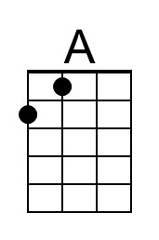 | 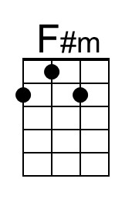
 |  |  |  |  |  |  | 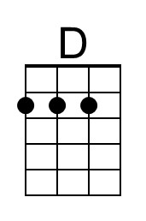 | 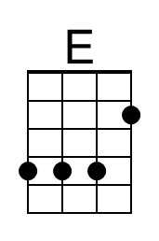
 |  |  |  |  |  |  | 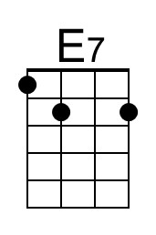 | 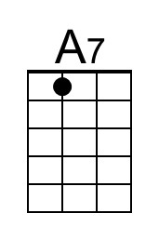
 |  |  |  |  |  |  | 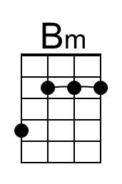
Bari | 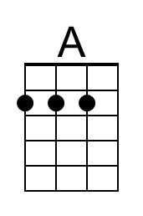 | 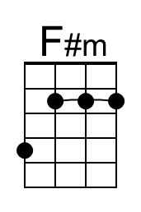 | 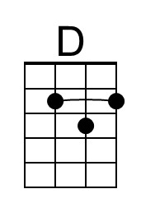 | 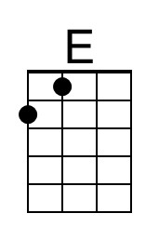 | 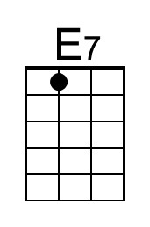 | 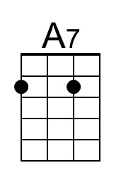 | 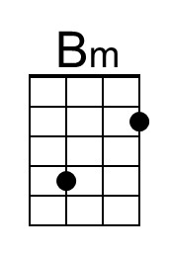

Love Will Keep Us Alive (A) – Page 2

A F#m | F#m
Now I've found you, there's no more empti-ness inside.
D E A A
When we're hungry, love will keep us a-live.
Instrumental
A F#m | F#m
Now I've found you, there's no more empti-ness inside.
D E A A7
When we're hungry, love will keep us a-live.

Chorus
D D F#m | F#m
I would die for you, __ climb the highest mountain.
Bm Bm E E7
Baby, there's nothin' I wouldn't do.

A F#m | F#m
I was standin' all alone against the world outside.
D E E7
You were searchin' for a place to hide.
A F#m | F#m
Lost and lonely, now you've given me the will to survive.
D E A A7
When we're hungry, love will keep us a-live

Outro
D E A | F#m
When we're hungry, love will keep us a-live.
D E A | A | A | A
When we're hungry, love will keep us a-live.

A transposition in the key of G is available on the following pages.
A capo will be necessary to play it with the Eagles in the key of A.
Love Will Keep Us Alive (G)
(Pete Vale, Jim Capaldi & Paul Carrack, late 80s-early 90s)
Love Will Keep Us Alive by The Eagles (1994) (A)
4/4 Time – Tempo 90 BPM

Intro (8 measures) G G Em Em C C D D  G Em Em  I was standin' all alone against the world outside.  C D D7  You were searchin' for a place to hide.  G Em Em  Lost and lonely, now you've given me the will to survive.  C D G G  When we're hungry, love will keep us a-live.  G Em Em  Don't you worry sometimes you've just gotta let it ride.  C D D7  The world is changin' right before your eyes.  G Em Em  Now I've found you, there's no more empti-ness inside.  C D G G7  When we're hungry, love will keep us a-live.  Chorus  C C Em Em  I would die for you, __ climb the highest mountain.  Am Am D D7  Baby, there's nothin' I wouldn't do. |  |  |  |  |  |  |  | 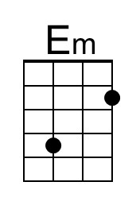
 |  |  |  |  |  |  | 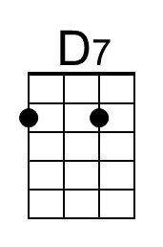
Bari |  | 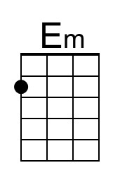 |  |  | 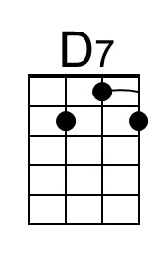

Love Will Keep Us Alive (G) – Page 2

G Em Em
Now I've found you, there's no more empti-ness inside.
C D G G
When we're hungry, love will keep us a-live.
Instrumental
G Em Em
Now I've found you, there's no more empti-ness inside.
C D G G7
When we're hungry, love will keep us a-live.

Chorus
C C Em Em
I would die for you, __ climb the highest mountain.
Am Am D D7
Baby, there's nothin' I wouldn't do.

G Em Em
I was standin' all alone against the world outside.
C D D7
You were searchin' for a place to hide.
G Em Em
Lost and lonely, now you've given me the will to survive.
C D G G7
When we're hungry, love will keep us a-live

Outro
C D G Em
When we're hungry, love will keep us a-live.
C D G G G G
When we're hungry, love will keep us a-live.

