Love Will Keep Us Alive
(Pete Vale, Jim Capaldi & Paul Carrack, late 80s-early 90s)
Love Will Keep Us Alive by The Eagles (1994) (A)
4/4 Time – Tempo 90 BPM

Intro (8 measures) | C | C | Am | Am | F | F | G | G  C Am | Am  I was standin' all alone against the world outside.  F G | G7  You were searchin' for a place to hide.  C Am | Am  Lost and lonely, now you've given me the will to survive.  F G C | C  When we're hungry, love will keep us a-live.  C Am | Am  Don't you worry sometimes you've just gotta let it ride.  F G | G7  The world is changin' right before your eyes.  C Am | Am  Now I've found you, there's no more empti-ness inside.  F G C | C7  When we're hungry, love will keep us a-live.  Chorus  F | F | Am | Am  I would die for you, __ climb the highest mountain.  Dm | Dm | G | G7  Baby, there's nothin' I wouldn't do. |  |  |  |  |  |  | 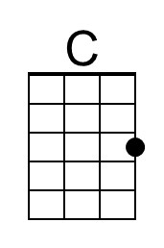
 |  |  |  |  |  |  | 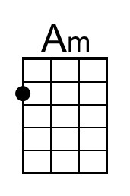
 |  |  |  |  |  |  | 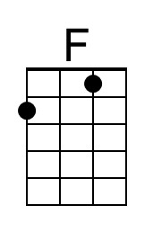
 |  |  |  |  |  |  | 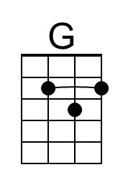
 |  |  |  |  |  |  | 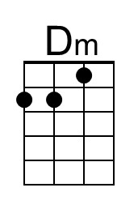
 |  |  |  |  |  |  | 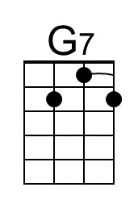
Bari | 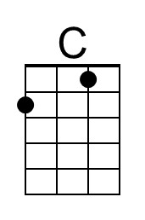 | 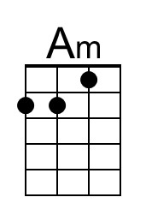 | 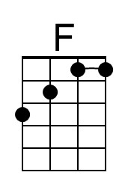 | 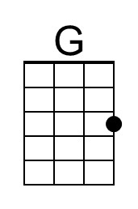 | 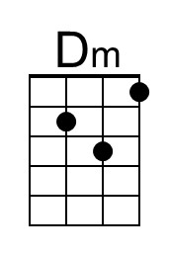 | 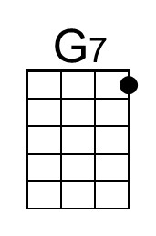

Love Will Keep Us Alive (C) – Page 2

C Am | Am
Now I've found you, there's no more empti-ness inside.
F G C | C
When we're hungry, love will keep us a-live.
Instrumental
C Am | Am
Now I've found you, there's no more empti-ness inside.
F G C | C7
When we're hungry, love will keep us a-live.

Chorus
F | F | Am | Am
I would die for you, __ climb the highest mountain.
Dm | Dm | G | G7
Baby, there's nothin' I wouldn't do.

C Am | Am
I was standin' all alone against the world outside.
F G | G7
You were searchin' for a place to hide.
C Am | Am
Lost and lonely, now you've given me the will to survive.
F G C | C7
When we're hungry, love will keep us a-live

Outro
F G C | Am
When we're hungry, love will keep us a-live.
F G C | C | C | C
When we're hungry, love will keep us a-live.

