Love and Honesty (C)
H39C
Love and Honesty by The Hawaiian Style Band (1992) (G)
4/4 & Tempo = 112 bpm
Island Strum
Intro (4 Measures) C | Am | C | Am |  C  Brown skin, light brown eyes,  Am  Golden hair from sunny skies  F G | G7  A haunting smile, a fresh pi-ka-ke lei. (pea-kah’-kay)  C  Soft touch, a warm embrace,  Am  Tears of joy they run down my face  F G | G7  I think of you every single day.  Chorus  F  There's more to life than getting by,  C C7  There’s times in life to really try,  F G7 C | C7  My love for you really made me see.  F  I won`t give up, won`t lose my dreams,  C C7  Your being there is every-thing  F G7 C | C  And I promise you, love and honesty. |  |  |  |  |  | 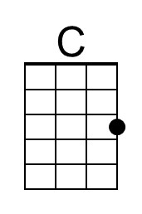 | 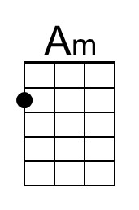
 |  |  |  |  |  | 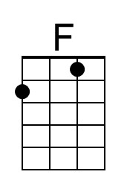 | 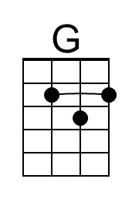
 |  |  |  |  |  | 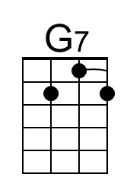 | 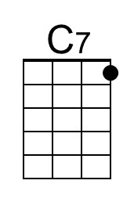
Bari | 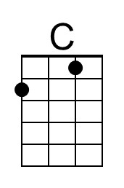 | 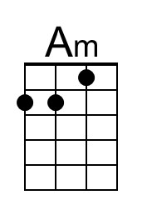 | 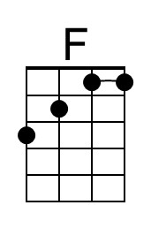 | 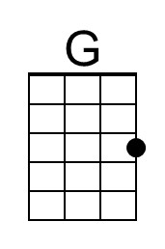 | 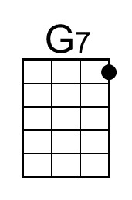 | 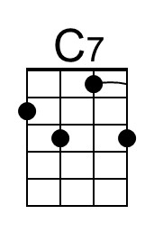

Love and Honesty – Page 2

C Am
Sunset, moonrise, calming seas under balmy skies
F G | G7
A walk with you beneath the whispering trees.
C
We laughed so much our throats were dry,
Am
And shared our hearts, teary-eyed
F G | G7
Let this night remind us there's a way.

Chorus
F
There's more to life than getting by,
C C7
There`s times in life to really try,
F G7 C | C7
My love for you really made me see.
F
I won`t give up, won`t lose my dreams,
C C7
Your being there is every-thing
F G7 C | C7
And I promise you, love and honesty.

Outro
F G7 C | C7
And I promise you, love and honesty.
( Ritard. )
F G7 C
And I promise you, love and honesty.

Love and Honesty (G)
H39G
Love and Honesty by The Hawaiian Style Band (1992) (G)
4/4 & Tempo = 112 bpm
Island Strum
Intro (4 Measures) G | Em | G | Em |  G  Brown skin, light brown eyes,  Em  Golden hair from sunny skies  C D | D7  A haunting smile, a fresh pi-ka-ke lei. (pea-kah’-kay)  G  Soft touch, a warm embrace,  Em  Tears of joy they run down my face  C D | D7  I think of you every single day.  Chorus  C  There's more to life than getting by,  G G7  There`s times in life to really try,  C D7 G | G7  My love for you really made me see.  C  I won`t give up, won`t lose my dreams,  G G7  Your being there is every-thing  C D7 G | G  And I promise you, love and honesty. |  |  |  |  |  |  | 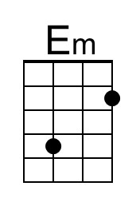
 |  |  |  |  |  |  | 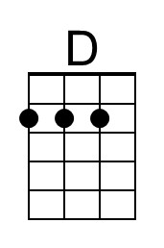
 |  |  |  |  |  | 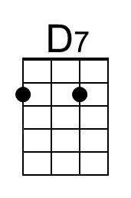
Bari |  | 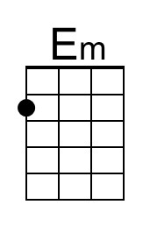 |  | 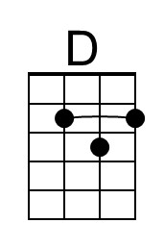 | 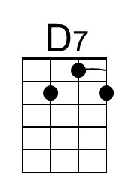

Love and Honesty (G) – Page 2

G Em
Sunset, moonrise, calming seas under balmy skies
C D | D7
A walk with you beneath the whispering trees.
G
We laughed so much our throats were dry,
Em
And shared our hearts, teary-eyed
C D | D7
Let this night remind us there's a way.

Chorus
C
There's more to life than getting by,
G G7
There`s times in life to really try,
C D7 G | G7
My love for you really made me see.
C
I won`t give up, won`t lose my dreams,
G G7
Your being there is every-thing
C D7 G | G7
And I promise you, love and honesty.

Outro
C D7 G | G7
And I promise you, love and honesty.
( Ritard. )
C D7 G
And I promise you, love and honesty.

