Love and Honesty
Love and Honesty by The Hawaiian Style Band (1992)
4/4 & Tempo = 120 bpm
Island Strum
Intro (8 Measures) C | Am | C | Am |  C  Brown skin, light brown eyes,  Am  Golden hair from sunny skies  F G7  A haunting smile, a fresh pi-ka-ke lei. (pea-kah’-kay)  C  Soft touch, a warm embrace,  Am  Tears of joy they run down my face  F G7  I think of you every single day.  Chorus  F  There's more to life than getting by,  C - C7  There`s times in life to really try,  F G7 C - C7  My love for you really made me see.  F  I won`t give up, won`t lose my dreams,  C - C7  Your being there is everything  F G7 C  And I promise you, love and honesty. | 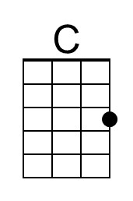 | 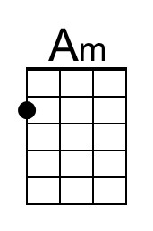
 | 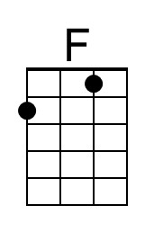 | 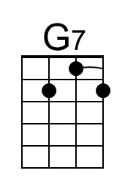
 | Bari
 | 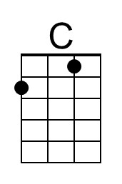 | 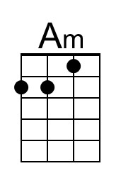
 | 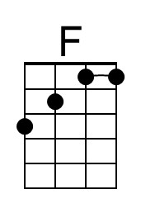 | 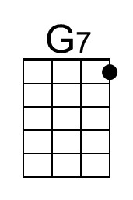

- - - - - -

There was a note on my song sheet from Feb 2020.
- Verse 1: Females
- Chorus 1: Males
- Verse 2: Both
- Chorus 2: Both
Love and Honesty – Page 2

C Am
Sunset, moonrise, calming seas under balmy skies
F G7
A walk with you beneath the whispering trees.
C
We laughed so much our throats were dry,
Am
And shared our hearts, teary-eyed
F G7
Let this night remind us there's a way.

Chorus
F
There's more to life than getting by,
C - C7
There`s times in life to really try,
F G7 C - C7
My love for you really made me see.
F
I won`t give up, won`t lose my dreams,
C - C7
Your being there is everything
F G7 C - C7
And I promise you, love and honesty.

Outro
F G7 C - C7
And I promise you, love and honesty.
( Ritard. )
F G7 C
And I promise you, love and honesty.

