**Love is All Around (Mary Tyler Moore Show Theme) (Sonny Curtis)**

**G C G C**

Who can turn the world on with her smile?

**G Em Am D**

Who can take a nothing day, and suddenly make it all seem worthwhile?

**Em C**

Well it's you girl, and you should know it

**Am D**

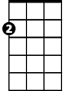

Am

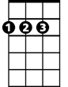

D

Em

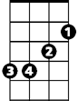

G



C

With each glance and every little movement you show it

**Chorus:**

**G C**

Love is all around, no need to waste it

**G C**

You can have the town, why don't you take it

**G Em C D G**

You're gonna make it after all

**G Em C D G**

You're gonna make it after all

**G C G C**

**BARITONE**



G



Em

C



D

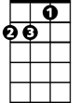

Am

How will you make it on your own?

**G Em Am D**

This world is awfully big, girl this time you're all alone

**Em C**

But it's time you started living

**Am D**

It's time you let someone else do some giving

**(Chorus)**

**G C G C**

You're the one most likely to succeed

**G Em Am D**

Just be sure to keep your head, 'cause girl, you know that's all you need

**Em C**

Everyone around adores you

**Am D**

Don't give up, the world is waiting for you

**(Chorus)**

**(First Verse + Chorus, extend last line)**