Love is a Rose (Neil Young, 1974) (C)
Love Is A Rose by Linda Ronstadt (1975)
2/2 Time – Tempo  = 68

Intro (4 down strums) C ↓ ↓ ↓ ↓  Chorus  C F C  Love is a rose but you better not pick it.  G C  Only grows when it's on the vine.  C F C  Handful of thorns and you'll know you've missed it.  G C  Lose your love when you say the word “mine.”  F C  I wanna see what's never been seen.  G C  I wanna live that age-old dream.  F C  Come on, boy, let's go together,  G C  Let's take the best right now.  C G C  Take the best right now. Chorus  F C  I wanna go to an old hoe-down  G C  Long ago in a western town.  F C  Pick me up 'cause my feet are dragging,  G C  Give me a lift and I'll hay your wagon. Chorus (2x)  Outro  C  Mine.  C | F C | | G C |  Love is a rose. Love is a rose.  C | F C | | G C |  Love is a rose. Love is a rose.  C | F C | | G | C  Love is a rose. Love is a rose. | 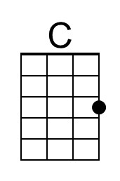
 | 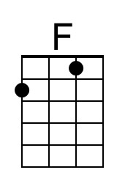
 | 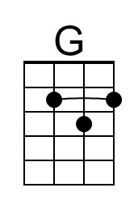
 | Bari
 | 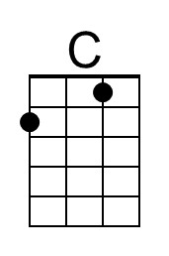
 | 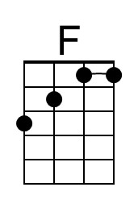
 | 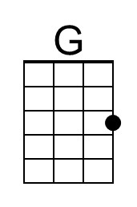

Love is a Rose (Neil Young, 1974) (G)
Love Is A Rose by Linda Ronstadt (1975)
2/2 Time – Tempo  = 68

Intro (4 down strums) G ↓ ↓ ↓ ↓

Chorus
G C G
Love is a rose but you better not pick it.
D G
Only grows when it's on the vine.
G C G
A handful of thorns and you'll know you've missed it.
D G
Lose your love when you say the word “mine.”

C G
I wanna see what's never been seen.
D G
I wanna live that age-old dream.
C G
Come on, boy, let's go together,
D G
Let's take the best right now.
G D G
Take the best right now. Chorus

C G
I wanna go to an old hoe-down,
D G
Long ago in a western town.
C G
Pick me up 'cause my feet are dragging,
D G
Give me a lift and I'll hay your wagon. Chorus (2x)

Outro
G
Mine.
G | C G | | D G |
Love is a rose. Love is a rose.
G | C G | | D G |
Love is a rose. Love is a rose.
G | C G | | D G |
Love is a rose. Love is a rose.
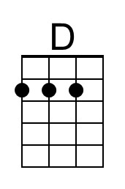
Bari
