Love is a Rose (Neil Young, 1974) (C)
Love Is A Rose by Linda Ronstadt (1975) (C)
2/2 Time – Tempo ❷ = 68 / ❶ = 145

Intro (4 down strums) C ↓ ↓ ↓ ↓  Chorus  C F C  Love is a rose but you better not pick it.  G C  Only grows when it's on the vine.  C F C  A handful of thorns and you'll know you've missed it.  G C  Lose your love when you say the word “mine.”  F C  I wanna see what's never been seen.  G C  I wanna live that age-old dream.  F C  Come on, boy, let's go together,  G C  Let's take the best right now;  C G C  Take the best right now. Chorus  F C  I wanna go to an old hoe-down  G C  Long ago in a western town  F C  Pick me up 'cause my feet are dragging  G C  Give me a lift and I'll hay your wagon. | 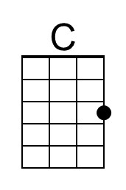
 | 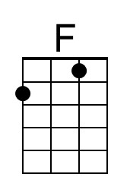
 | 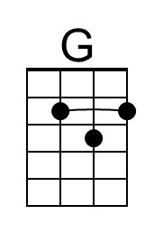
 | Bari
 | 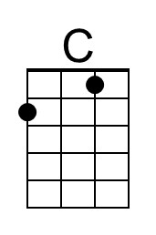
 | 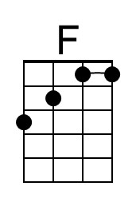
 | 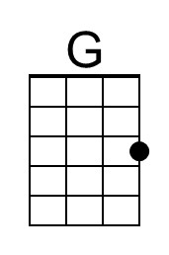

Love Is A Rose – Page 2

Chorus
C F C
Love is a rose but you better not pick it.
G C
Only grows when it's on the vine.
C F C
A handful of thorns and you'll know you've missed it.
G C
Lose your love when you say the word “mine.”

C F C
Love is a rose but you better not pick it.
G C
Only grows when it's on the vine.
C F C
A handful of thorns and you'll know you've missed it.
G C | C |
Lose your love when you say the word “mine;” “mine.”

Outro
C | F C | | G C |
Love is a rose. Love is a rose
C | F C | | G C |
Love is a rose. Love is a rose
C | F C | | G | C
Love is a rose. Love is a rose.

- - - - -

Good picking song for a banjolele.

