Lover of Mine (Malani Bilyeu, Gaylord Holomalia)
Lover of Mine by Israel "IZ" Kamakawiwo'ole from “N Dis Life” (1969)
4/4 Time – Tempo 120 bpm

Intro (Last two lines) C . . . | F | F | C | C | G | G | F | C |  C F | F C | C  _ Lover of mine, over the sea.  G | G C | C7  Deep blue ocean, waves in motion.  F | F C | C  _ Seems so long since I’ve seen you.  G | G F | C  Some-day you’ll be here with me.  C F | F C | C  _ Lover of mine, where can you be.  G | G C | C7  Welcome summer, sunny weather.  F | F C | C  _ Where have you gone, I look to the sea.  G | G F | C  Some-day, you’ll come home to me.  Instrumental verse  C F | F C | C  _ Lover of mine, where can you be.  G | G C | C7  Welcome summer, sunny weather.  F | F C | C  _ Where have you gone, I look to the sea.  G | G F | C  Some-day, you’ll come home to me.  G | G F | C  Some-day, you’ll come home to me. |  |  |  |  |  | 
 |  |  |  |  |  | 
 |  |  |  |  |  | 
 |  |  |  |  |  | 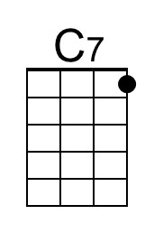
Bari | 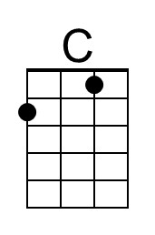 |  |  | 