MTA (Kingston Trio) (C)

C  Let me tell you of a story  F  'bout a man named Charlie  C G7  On a tragic and fateful day.  C  He put ten cents in his pocket,  F  kissed his wife and family,  C G7 C  Went to ride on the M - T - A  Chorus:  C  But will he ever return?  F  No, he'll never return,  C G7  And his fate is still unlearned.  C  He may ride forever  F  'neath the streets of Boston,  C G7 C  He's the man who never returned.  C  Charlie handed in his dime  F  At the Scully Square Station,  C G7  And he changed for Jamaica Plain.  C  When he got there the conductor told him,  F  "One more nickel!"  C G7 C  Charlie couldn't get off of that train.  Chorus. | C  Now all night long  F  Charlie rides through the stations,  C G7  Crying, "What will become of me?  C  How can I afford to see  F  My sister in Chelsey,  C G7 C  Or my brother in Roxbury?" Chorus.  C  Charlie's wife goes down  F  To the Scully Square Station,  C G7  Every day at a quarter past two.  C  And through the open window  F  She hands Charlie his sandwich  C G7 C  As the train goes rumbling through.  Chorus.  C  Now you citizens of Boston,  F  Don't you think it's a scandal,  C G7  How the people have to pay and pay?  C F  Fight the fare increase, vote for George  O'Brien,  C G7 C  Get poor Charlie off the M - T - A!  Chorus.  C G7 C  He's the man who never returned. | 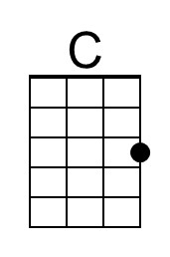
 |  | 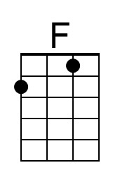
 |  | 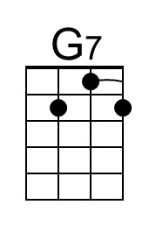
 |  | Bari
 |  | 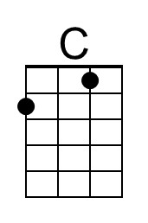
 |  | 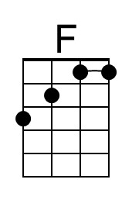
 |  | 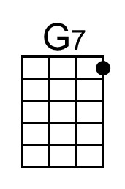

MTA (Kingston Trio) (G)

G  Let me tell you of a story  C  'bout a man named Charlie  G D7  On a tragic and fateful day.  G  He put ten cents in his pocket,  C  kissed his wife and family,  G D7 G  Went to ride on the M - T - A  Chorus:  G  But will he ever return?  C  No, he'll never return,  G D7  And his fate is still unlearned.  G  He may ride forever  C  'neath the streets of Boston,  G D7 G  He's the man who never returned.  G  Charlie handed in his dime  C  At the Scully Square Station,  G D7  And he changed for Jamaica Plain.  G  When he got there the conductor told him,  C  "One more nickel!"  G D7 G  Charlie couldn't get off of that train.  Chorus. | G  Now all night long  C  Charlie rides through the stations,  G D7  Crying, "What will become of me?  G  How can I afford to see  C  My sister in Chelsey,  G D7 G  Or my brother in Roxbury?" Chorus.  G  Charlie's wife goes down  C  To the Scully Square Station,  G D7  Every day at a quarter past two.  G  And through the open window  C  She hands Charlie his sandwich  G D7 G  As the train goes rumbling through.  Chorus.  G  Now you citizens of Boston,  C  Don't you think it's a scandal,  G D7  How the people have to pay and pay?  G C  Fight the fare increase, vote for George  O'Brien,  G D7 G  Get poor Charlie off the M - T - A!  Chorus.  G D7 G  He's the man who never returned. | 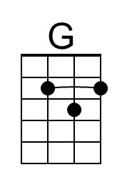
 |  | 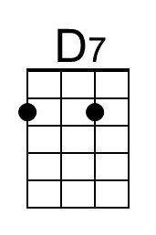
 |  | Bari
 |  | 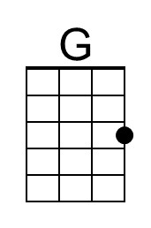
 |  | 