MTA (Kingston Trio) (G)

G  Let me tell you of a story  C  'bout a man named Charlie  G D7  On a tragic and fateful day.  G  He put ten cents in his pocket,  C  kissed his wife and family,  G D7 G  Went to ride on the M - T - A  Chorus:  G  But will he ever return?  C  No, he'll never return,  G D7  And his fate is still unlearned.  G  He may ride forever  C  'neath the streets of Boston,  G D7 G  He's the man who never returned.  G  Charlie handed in his dime  C  At the Scully Square Station,  G D7  And he changed for Jamaica Plain.  G  When he got there the conductor told him,  C  "One more nickel!"  G D7 G  Charlie couldn't get off of that train.  Chorus. |  |  | G  Now all night long  C  Charlie rides through the stations,  G D7  Crying, "What will become of me?  G  How can I afford to see  C  My sister in Chelsey,  G D7 G  Or my brother in Roxbury?"  Chorus.  G  Charlie's wife goes down  C  To the Scully Square Station,  G D7  Every day at a quarter past two.  G  And through the open window  C  She hands Charlie his sandwich  G D7 G  As the train goes rumbling through.  Chorus.  G  Now you citizens of Boston,  C  Don't you think it's a scandal,  G D7  How the people have to pay and pay?  G C  Fight the fare increase, vote for George O'Brien,  G D7 G  Get poor Charlie off the M - T - A!  Chorus.  G D7 G  He's the man who never returned. |  |  | 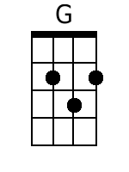
 |  |  |  |  |  | 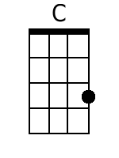
 |  |  |  |  |  | 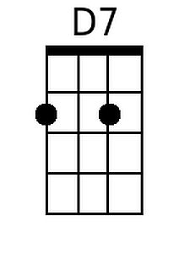
Bari
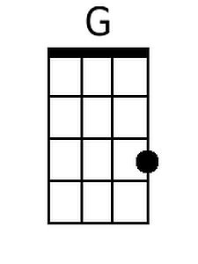 | 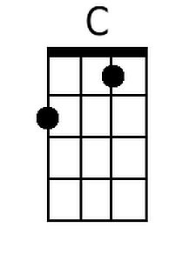 | 