Mahalo Nui
Words by Harold Roes; Music by Carol Roes and Lloyd Stone
San Francisco, CA : Groene Music Pub. Co., ©1956
Key of C

2 2 4  Vamp: D7, G7, C (2x)  C G7  Mahalo Nui for a lovely holiday  C  Mahalo Nui as I go a-way  G7  Hawaiian memories will haunt me evermore  C C7  A fond aloha as I leave your shore  F C  You gave me flower leis with Hawaii's smile  D7 G G7  You made the sunny days seems so worth-while  C G7  Mahalo Nui and as I now depart  C  Mahalo Nui with all my heart.  Vamp: D7, G7, C (2x)  "Mahalo Nui" sung by the Veteran Kanikapila Singers of Kaua'i  "Mahalo Nui" sung by Bill Ali'iloa Lincoln and His Hawaiians from their LP, "Mahalo Nui-Thank You Very Much" (Tradewinds Records, 2008).  Baritone |  |  |  |  | 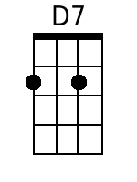  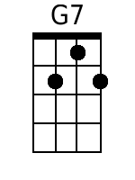  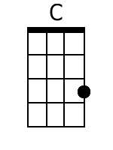  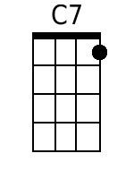  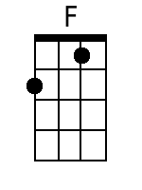  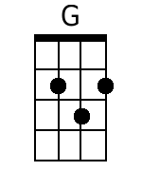
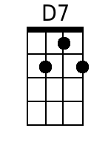 | 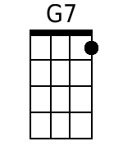 | 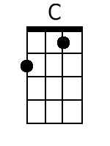 | 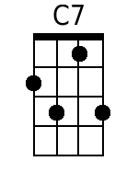 | 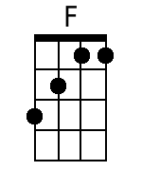 | 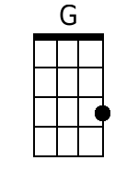

Mahalo Nui
Words by Harold Roes; Music by Carol Roes and Lloyd Stone
San Francisco, CA : Groene Music Pub. Co., ©1956
Key of F

2 2 4  Vamp: G7, C7, F (2x)  F C7  Mahalo Nui for a lovely holiday  F  Mahalo Nui as I go a-way  C7  Hawaiian memories will haunt me evermore  F F7  A fond aloha as I leave your shore  Bb F  You gave me flower leis with Hawaii's smile  G7 C C7  You made the sunny days seems so worth-while  F C7  Mahalo Nui and as I now depart  F  Mahalo Nui with all my heart.  Vamp: G7, C7, F (2x)  "Mahalo Nui" sung by the Veteran Kanikapila Singers of Kaua'i  "Mahalo Nui" sung by Bill Ali'iloa Lincoln and His Hawaiians from their LP, "Mahalo Nui-Thank You Very Much" (Tradewinds Records, 2008). | 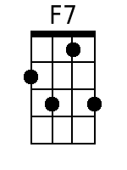  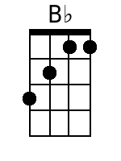

Baritone
 |  |  | 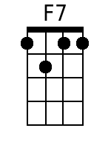 | 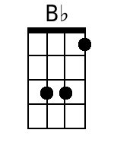

Mahalo Nui
Words by Harold Roes; Music by Carol Roes and Lloyd Stone
San Francisco, CA : Groene Music Pub. Co., ©1956
Key of G
2 2 4  Vamp: A7, D7, G (2x)  G D7  Mahalo Nui for a lovely holiday  G  Mahalo Nui as I go a-way  D7  Hawaiian memories will haunt me evermore  G G7  A fond aloha as I leave your shore  C G  You gave me flower leis with Hawaii's smile  A7 D D7  You made the sunny days seems so worth-while  G D7  Mahalo Nui and as I now depart  G  Mahalo Nui with all my heart.  Vamp: A7, D7, G (2x)  "Mahalo Nui" sung by the Veteran Kanikapila Singers of Kaua'i  "Mahalo Nui" sung by Bill Ali'iloa Lincoln and His Hawaiians from their LP, "Mahalo Nui-Thank You Very Much" (Tradewinds Records, 2008). | 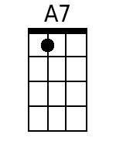  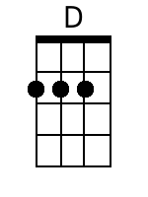

Baritone
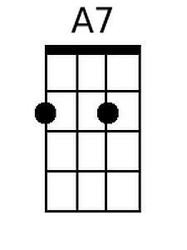 |  |  |  |  | 