Mairzy Doats (Milton Drake, Al Hoffman and Jerry Livingston, 1943) (C)

Intro (4 measures) Dm7 G7 C G7  Chorus  C Gdim7  Mairzy doats and dozy doats, and liddle lamzy divey,  Dm7 G7 C G7  A kiddley divey too, wouldn't you?  C Gdim7  Mairzy doats and dozy doats, and liddle lamzy divey,  Dm7 G7 C  A kiddley divey too, wouldn't you?  Gm7 C7 Gm7 C7  If the words sound queer, and funny to your ear,  F  A little bit jumbled and jivey,  Am7 D7 Am7 D7  Sing " Mares eat oats and does eat oats  G Dm7 G7  And little lambs eat ivy.  Dm7 G7 C G7  A kid will eat ivy too wouldn't you?" Oh!  Repeat Chorus (2x)  Outro  Dm7 G7 C  A kiddley divey too, wouldn't you? |  |  |  |  |  | 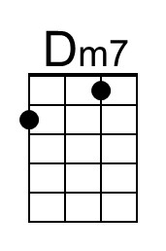 | 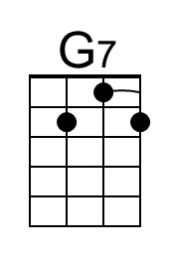
 |  |  |  |  |  | 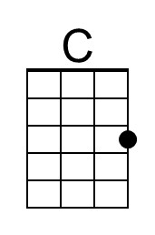 | 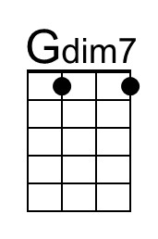
 |  |  |  |  |  | 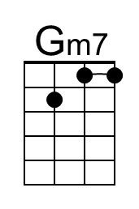 | 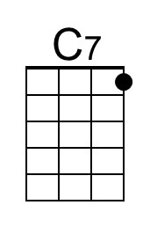
 |  |  |  |  |  | 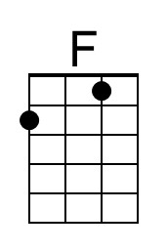 | 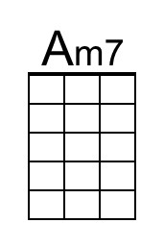
 |  |  |  |  |  | 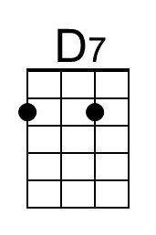 | 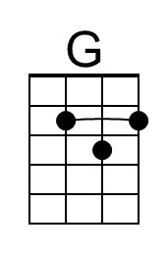
 |  | Bari | 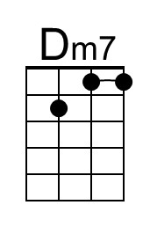 | 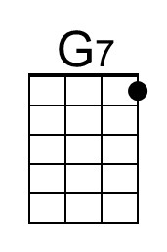 | 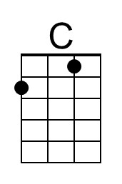 | 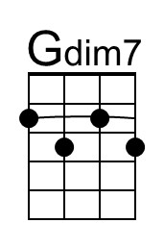 | 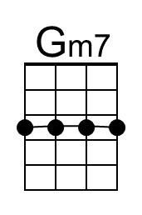
 |  |  | 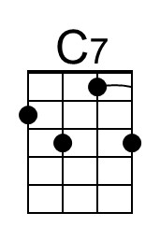 | 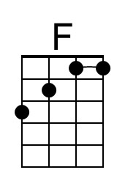 | 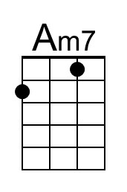 | 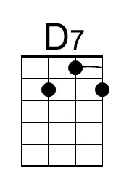 | 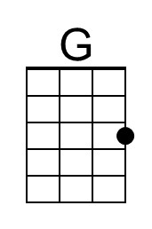

Mairzy Doats (Milton Drake, Al Hoffman and Jerry Livingston, 1943) (G)

Intro (4 measures) Am7 D7 G D7

Chorus
G Ddim7
Mairzy doats and dozy doats, and liddle lamzy divey,
Am7 D7 G D7
A kiddley divey too, wouldn't you?
G Ddim7
Mairzy doats and dozy doats, and liddle lamzy divey,
Am7 D7 G D7
A kiddley divey too, wouldn't you?

Dm7 G7 Dm7 G7
If the words sound queer, and funny to your ear,
C
A little bit jumbled and jivey,
Em7 A7 Em7 A7
Sing " Mares eat oats and does eat oats
D Am7 D7
And little lambs eat ivy.
Am7 D7 G D7
A kid will eat ivy too wouldn't you?" Oh!

Repeat Chorus

Outro
Am7 D7 G
A kiddley divey too, wouldn't you?

 |  |  |  |  |  |  | 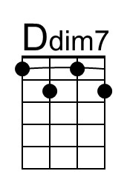
 |  |  |  |  |  |  | 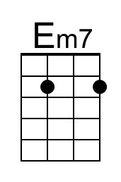
 |  |  |  |  |  | 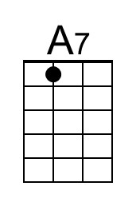 | 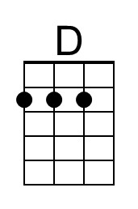
 |  | Bari |  |  |  | 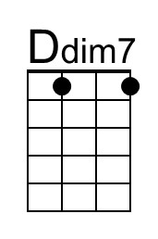
 |  |  |  |  | 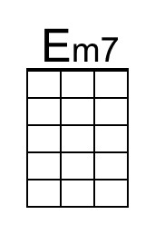 | 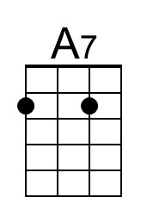 | 