**Makin' Whoopee (Gus Kahn & Walter Donaldson)**

**C Am Dm G7**

Another bride, another June

**C C7 F Fm**

Another sunny honeymoon

**C Am Dm G7**

Another season, another reason

**C Cdim Dm G7**

For maki n' whoopee

**C Am Dm G7**

You get some shoes, a little rice

**C C7 F Fm**

The groom's so nervous he answers twice

**C Am Dm G7**

It's really thrillin' that he's so willin'

**C F Fm7 C**

For makin' whoopee

**C7 Dm**

Picture a little love nest

**Dm C**

Down where the roses cling

**C7 Dm**

Picture that same love nest

**Dm G7**

And see what a year will bring

**C Am Dm G7**

He's doin' dishes and baby clothes

**C C7 F Fm**

He's so ambitious, he even sews

**C Am Dm G7**

Just don't forget, folks, that's what you get, folks,

**C Cdim Dm G7**

For makin' whoopee

**C Am Dm G7**

Another year or maybe less

**C C7 F Fm**

What's this I hear? Well, can't you guess?

**C Am Dm G7**

She feels neglected and he's suspected

**C Cdim Dm G7**

Of makin' whoopee

**BARITONE**

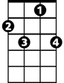

C7

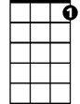

G7

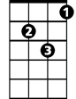

Dm

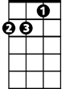

Am

C



**C Am Dm G7**

She sits alone 'most every night

**C C7 F Fm**

He doesn't phone her, he doesn't write

**C Am Dm G7**

He says he's "busy" but she says "is he?"

**C F Fm7 C**

He's makin' whoopee

**C7 Dm**

He doesn't make much money

**Dm C**

Only a five-thousand per

**C7 Dm**

Some judge who thinks he's funny

**Dm G7**

Told him he got to pay six to her

**C Am Dm G7**

He says: "Now judge, suppose I fail."

**C C7 F Fm**

The judge says: "Budge right into jail!

**C Am Dm G7**

You'd better keep her I think it's cheaper

**C Cdim Dm G7**

Than makin' whoopee

F

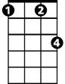

Fm

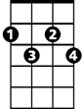

Cdim

Fm7

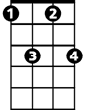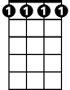

Fm7

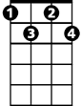

Cdim

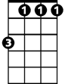

Fm



F

**C Am Dm G7**

Just don't forget, folks, that's what you get, folks,

**C F Fm7 C**

For makin' whoopee



Dm

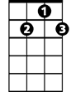

G7



C7



C

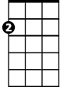

Am