Makin' Whoopee (Gus Kahn & Walter Donaldson) (C)

C Am Dm G7 C C7 F Fm  Another bride, another June, another sunny honey-moon  C Am Dm G7 C Cdim Dm G7  Another season, another reason, for maki n' whoopee  C Am Dm G7  You get some shoes, a little rice  C C7 F Fm  The groom's so nervous he answers twice  C Am Dm G7 C F Fm7 C  It's really thrillin' that he's so willin' for makin' whoopee.  C7 Dm Dm C  Picture a little love nest, down where the roses cling.  C7 Dm Dm G7  Picture that same love nest , and see what a year will bring.  C Am Dm G7  He's doin' dishes and baby clothes,  C C7 F Fm  He's so ambitious, he even sews  C Am Dm G7  Just don't forget, folks, - that's what you get, folks,  C Cdim Dm G7  For makin' whoopee. |  |  |  |  |  | 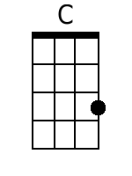 | 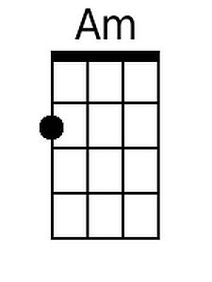
 |  |  |  |  |  | 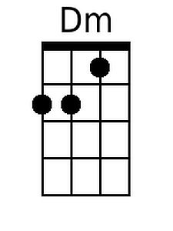 | 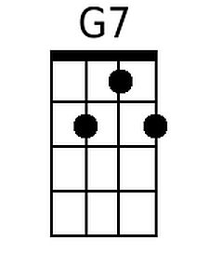
 |  |  |  |  |  | 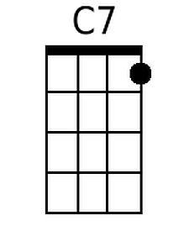 | 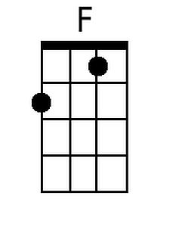
 |  |  |  |  |  | 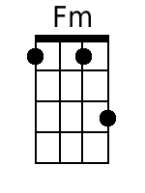 | 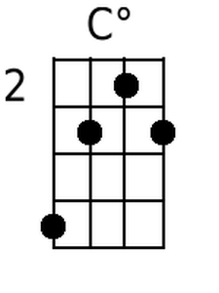
 |  |  |  |  |  | 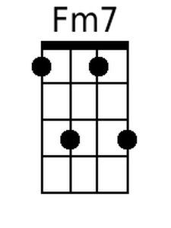
Bari
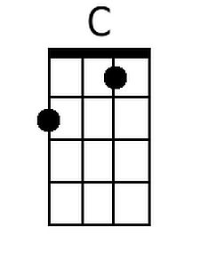 | 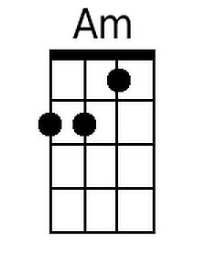 | 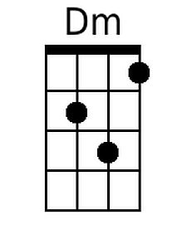 | 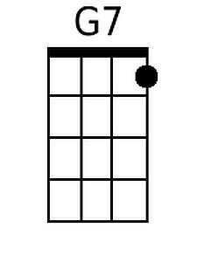 | 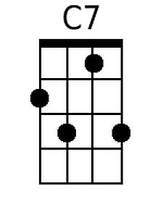
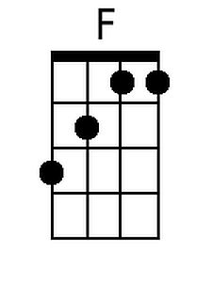 | 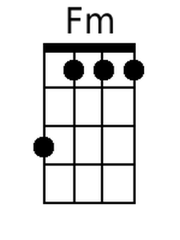 | 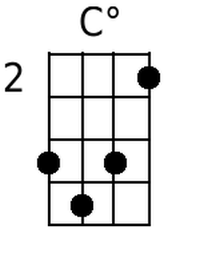 | 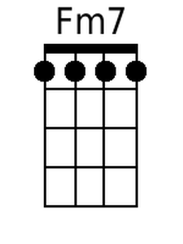

Makin’ Woopee (C) - Page 2
C Am Dm G7
Another year or maybe less
C C7 F Fm
What's this I hear? Well, can't you guess?
C Am Dm G7
She feels neglected and he's suspected
C Cdim Dm G7
Of makin' whoopee

C Am Dm G7
She sits alone 'most every night
C C7 F Fm
He doesn't phone her, he doesn't write
C Am Dm G7
He says he's "busy" but she says "is he?"
C F Fm7 C
He's makin' whoopee

C7 Dm Dm C
He doesn't make much money, only a five-thousand per.
C7 Dm Dm G7
Some judge who thinks he's funny, told him he got to pay six to her.

C Am Dm G7
He says: "Now judge, suppose I fail."
C C7 F Fm
The judge says: "Budge right into jail!
C Am Dm G7
You'd better keep her I think it's cheaper
C Cdim Dm G7
Than makin' whoopee
C Am Dm G7
Just don't forget, folks, that's what you get, folks,
C F Fm7 C
For makin' whoopee.

_____
Some great chord progressions in this song:

Verse (Nashville Notation and Roman Notation):
1 | 6m | 2m | 5(7) |  | I | vi | ii | V7
1 | 1(7) | 4 | 4m |  | I | I 7 | IV | iv
1 | 6m | 2m | 5(7) |  | I | vi | ii | V7
1 | 1 dim | 2m | 5(7) |  | I | I dim | ii | V7

Bridge (Nashville Notation and Roman Notation):
1(7) | 2m | 2m | 1 |  | I7 | ii | ii | I
1(7) | 2m | 2m | 5(7) |  | I7 | ii | ii | V7

Makin' Whoopee (Gus Kahn & Walter Donaldson) (G)

G Em Am D7 G G7 C Cm  Another bride, another June, Another sunny honey-moon  G Em Am D7 G Gdim Am D7  Another season, another reason, for maki n' whoopee  G Em Am D7  You get some shoes, a little rice,  G G7 C Cm  The groom's so nervous he answers twice.  G Em Am D7 G C Cm7 G  It's really thrillin' that he's so willin' for makin' whoopee  G7 Am Am G  Picture a little love nest, down where the roses cling.  G7 Am Am D7  Picture that same love nest, and see what a year will bring  G Em Am D7  He's doin' dishes and baby clothes  G G7 C Cm  He's so ambitious, he even sews  G Em Am D7  Just don't forget, folks, that's what you get, folks,  G Gdim Am D7  For makin' whoopee! |  |  |  |  |  |  | 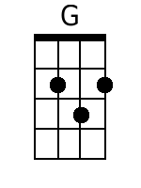 | 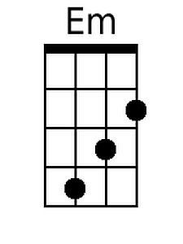
 |  |  |  |  |  |  |  | 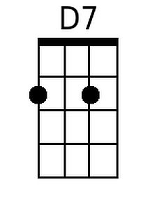
 |  |  |  |  |  |  | 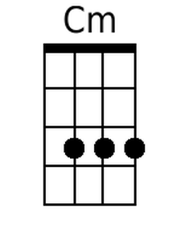 | 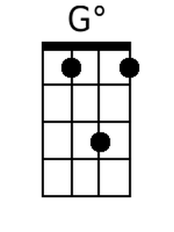
 |  |  |  |  |  |  | 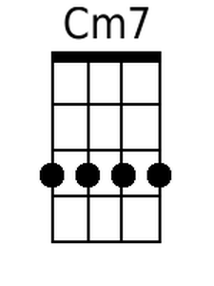
Bari
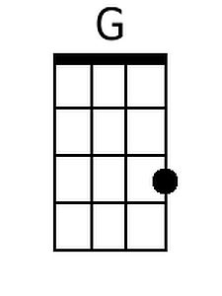 | 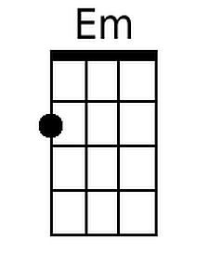 |  | 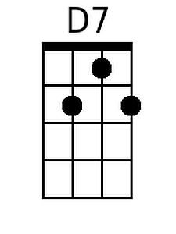
 | 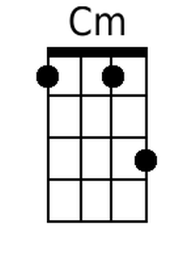 | 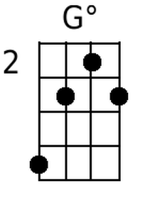 | 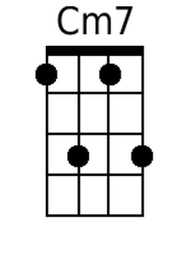

Makin’ Woopee (G) - Page 2
G Em Am D7
Another year or maybe less,
G G7 C Cm
What's this I hear? Well, can't you guess?
G Em Am D7
She feels neglected and he's suspected,
G Gdim Am D7
Of makin' whoopee.

G Em Am D7
She sits alone 'most every night,
G G7 C Cm
He doesn't phone her, he doesn't write,
G Em Am D7
He says he's "busy" but she says "is he?"
G C Cm7 G
He's makin' whoopee.

G7 Am Am G
He doesn't make much money, only a five-thousand per.
G7 Am Am D7
Some judge who thinks he's funny, told him he got to pay six to her.

G Em Am D7
He says: "Now judge, suppose I fail."
G G7 C Cm
The judge says: "Budge right into jail!
G Em Am D7
You'd better keep her I think it's cheaper
G Gdim Am D7
Than makin' whoopee
G Em Am D7
Just don't forget, folks, that's what you get, folks,
G C Cm7 G
For makin' whoopee!

_____
Some great chord progressions in this song:

Verse (Nashville Notation and Roman Notation):
1 | 6m | 2m | 5(7) |  | I | vi | ii | V7
1 | 1(7) | 4 | 4m |  | I | I 7 | IV | iv
1 | 6m | 2m | 5(7) |  | I | vi | ii | V7
1 | 1 dim | 2m | 5(7) |  | I | I dim | ii | V7

Bridge (Nashville Notation and Roman Notation):
1(7) | 2m | 2m | 1 |  | I 7 | ii | ii | I
1(7) | 2m | 2m | 5(7) |  | I 7 | ii | ii | V7

