Mammas Don't Let Your Babies Grow Up To Be Cowboys
Written by Ed and Patsy Bruce, Recorded by Willie Nelson

Chorus  C F  Mammas don't let your babies grow up to be cowboys  G7  Don't let them pick guitars and drive in old trucks  C  Make 'em be doctors and lawyers and such  C F  Mammas don't let your babies grow up to be cowboys  G7  They'll never stay home and they're always alone  C  Even with someone they love  C F  1. Cowboys ain't easy to love and they're harder to hold  G7 C  And they'd rather give you a song than diamonds or gold  Lone Star belt buckles and old faded Levis  F  And each night begins a new day  G7  And if you don't understand him and he don't die young  C  He'll probably just ride a-way. Chorus  C F  2. A cowboy loves smokey old pool rooms and clear mountain mornings  G7 C  Little warm puppies and children and girls of the night  Them that don't know him won't like him  F  And them that do sometimes won't know how to take him  G7  He's not wrong he's just different and his pride won't let him  C  Do things to make you think he's right. Chorus |  |  |  |  |  | 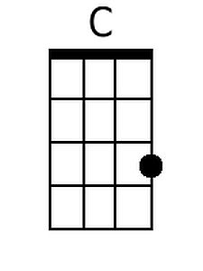  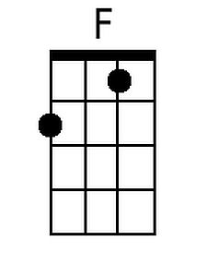  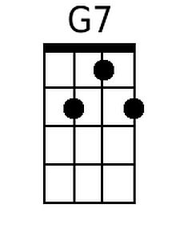
Bari
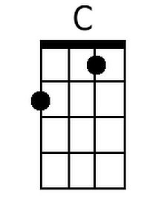 | 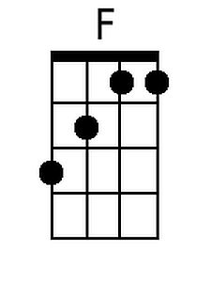 | 