**Manuela Boy (Johnny Moore)**

**VAMP: D7 G7 C (2X)**

**C**

Papa works for the stevedore,

Mama makes the leis

**G7**

Sister goes with the Haole boy

**C**

Comes home any old time - Auwe no ho'i

**Chorus:**

**C**

Manuela boy, my dear boy

You no more hila hila

**G7**

No more five cents, no more house

**C**

You go Aala Park hi’amoe

**C**

Junior goes to the beach all day

To spahk dat wahines in bikinis

**G7**

He wears dark glasses and a coconut hat

**C**

You no can see where his eyeballs at

**(Chorus)**

**C**

Well Grandpa he works in the kalo patch

And Grandma she makes the poi

**G7**

Chilli peppa watah and beef stew rice,

**C**

Pipikaula on the side - No ka oi

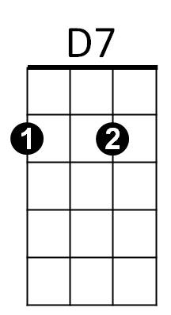**(Chorus)**

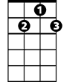

G7



C

**(OPTIONAL VERSES)**

**C**

Mama works at the big hotel

Sister teaches school

**G7**

Brother works for the HPD

**C**

Papa makes his money playing pool

**C**

I want to marry this wahine I know

Her name is Haunani Ho

**G7**

I told my papa and he said no

Haunani is your sister

**C**

But your mama don't know

**C**

I told my mama what my papa had said

She said no hila hila

**G7**

You can marry Haunani Ho

Your papa's not your papa

**C**

But your papa don't know

**(Chorus)**

**G7 C**

You go Aala Park hi’amoe

**VAMP: D7 G7 C (2X)**

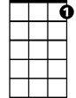

G7



D7

C



**BARITONE**