Margaritaville (Jimmy Buffett) (C)

Intro C F G7 C  C  Nibblin' on sponge cake, watchin' the sun bake;  G7  All of those tourists covered with oil.  Strummin' my FOUR string on my front porch swing.  C C7  Smell those shrimp. They're beginnin' to boil.  Chorus  F G7 C C7  Wasted a- way again in Marga- ritaville,  F G7 C C7  Searchin' for my lost shaker of salt.  F G7 C G F  Some people claim that there's a wo-man to blame,  G7 C  1. But I know, it's nobody's fault.  2. Now I think, - it could be my fault.  3. But I know, it's my own dang fault.  C  Don't know the reason, stayed here all season  C G7  Nothing to show but this brand new tat- too.  But it's a real beauty, a Mexican cutie,  C C7  How it got here I haven't a clue. Chorus  C  I blew out my flip flop, stepped on a pop top,  G7  Cut my heel, and I had to cruise on back home.  But there's booze in the blender, and soon it will render  C C7  That frozen concoction that helps me hang on. Chorus  Outro  F G7  Yes, and some people claim that there's a  C G F G7 C  Wo-man to blame, But I know, it's my own dang fault.  Tag C F G7 C | 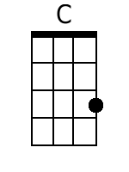 | 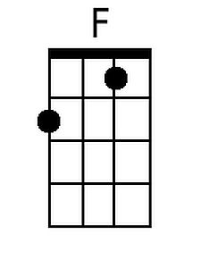
 | 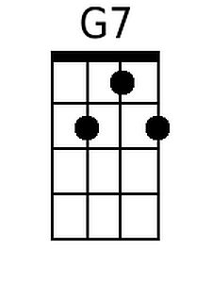 | 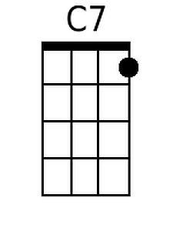
 | 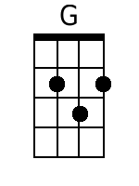
 | Baritone
 | 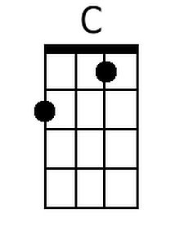 | 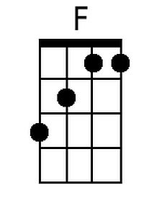
 | 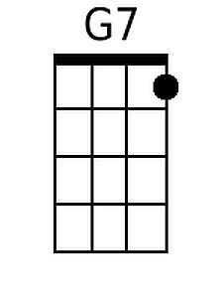 | 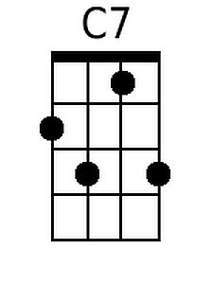
 | 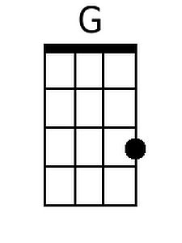

Margaritaville (Jimmy Buffett) (G)

Intro G C D7 G

G
Nibblin' on sponge cake, watchin' the sun bake;
D7
All of those tourists covered with oil.

Strummin' my FOUR string on my front porch swing.
G G7
Smell those shrimp. They're beginnin' to boil.

Chorus
C D7 G G7
Wasted a- way again in Marga- ritaville,
C D7 G G7
Searchin' for my lost shaker of salt.
C D7 G D C
Some people claim that there's a wo-man to blame,
D7 G
1. But I know, it's nobody's fault.
2. Now I think, - it could be my fault.
3. But I know, it's my own dang fault.

G
Don't know the reason, stayed here all season
G D7
Nothing to show but this brand new tat- too.

But it's a real beauty, a Mexican cutie,
G G7
How it got here I haven't a clue. Chorus

G
I blew out my flip flop, stepped on a pop top,
D7
Cut my heel, and I had to cruise on back home.

But there's booze in the blender, and soon it will render
G G7
That frozen concoction that helps me hang on. Chorus

Outro
C D7
Yes, and some people claim that there's a
G D C D7 G
Wo-man to blame, But I know, it's my own dang fault.

Tag G C D7 G
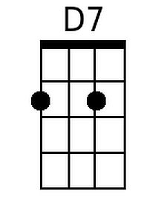
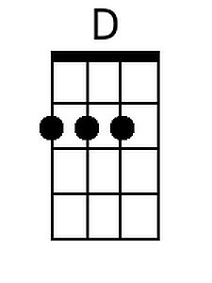
Baritone
