
Marie Laveau (Shel Silverstein / Baxter Taylor) (C)

INTRO (TALK):
The most famous of the voodoo queens that ever existed
Is Marie Laveau, down in Louisana
There's a lot of weird, ungodly tales about Marie,
She's supposed to have a lot of magic potions, spells and curses.…

C  Down in Louisiana, where the black trees grow  Lives a voodoo lady named Marie Laveau  F  She got a black cat tooth and a Mojo bone  C  And anyone who wouldn't leave her alone  G F C  She'd go (growl) another man done gone.  C  She lives in a swamp in a hollow log  With a one-eyed snake and a three-legged dog  F  She's got a bent, bony body and stringy hair  C  If she ever seen y'all messin' 'round there  G F C  She'd go (growl) another man done gone.  F  And then one night when the moon was black  C  Into the swamp come Handsome Jack  D  A no-good man like you all know  G  And He was lookin' around for Marie Laveau.  C  He said, “Marie Laveau, you lovely witch  Gimme a little a little charm that'll make me rich”  F  Gimme a million dollars and I tell you what I'll do  C  This very night, I'm gonna marry you  G F C  Then It'll be (growl) another man done gone. |  |  |  |  | F  So Marie done some magic,  and she shook a little sand  C  Made a million dollars and she put it in his hand  D  Then she giggled and she wiggled,  and she said Hey, Hey  G  I'm gettin' ready for my weddin' day.  C  But old Handsome Jack he said “Goodbye Marie,  You're too damned ugly for a rich man like me”  F  Then Marie started mumblin', her fangs started gnashin'  C  Her body started tremblin', and her eyes started flashin'  G F C  And she went (growl) another man done gone.  C  So if you ever git down where the black trees grow  And meet a voodoo lady named Marie Laveau  F  If she ever asks you to make her your wife  C  Man, you better stay with her for the rest of your life  G F C  Or it'll be (growl) another man done gone.  G F C  Or it'll be (growl) another man done gone.
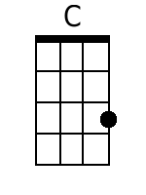 | 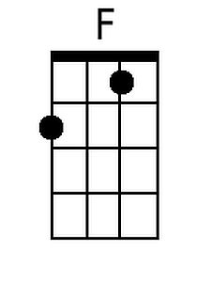 | 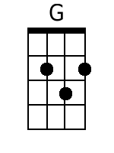 | 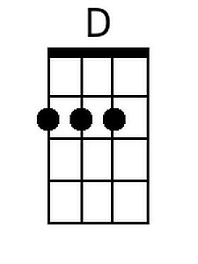 | Bari |  | 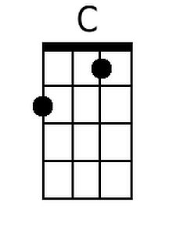 | 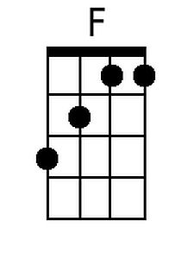 | 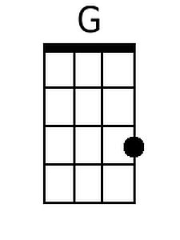  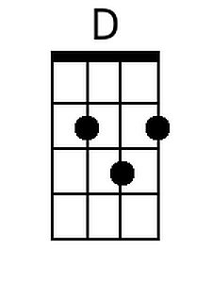

Marie Laveau (Shel Silverstein / Baxter Taylor) (G)

INTRO (TALK):
The most famous of the voodoo queens that ever existed
Is Marie Laveau, down in Louisana
There's a lot of weird, ungodly tales about Marie,
She's supposed to have a lot of magic potions, spells and curses....

G  Down in Louisiana, where the black trees grow  Lives a voodoo lady named Marie Laveau  C  She got a black cat tooth and a Mojo bone  G  And anyone who wouldn't leave her alone  D C G  She'd go (growl) another man done gone.  G  She lives in a swamp in a hollow log  With a one-eyed snake and a three-legged dog  C  She's got a bent, bony body and stringy hair  G  If she ever seen y'all messin' 'round there  D C G  She'd go (growl) another man done gone.  C  And then one night when the moon was black  G  Into the swamp come Handsome Jack  A  A no-good man like you all know  D  And He was lookin' around for Marie Laveau.  G  He said, "Marie Laveau, you lovely witch  Gimme a little a little charm that'll make me rich"  C  Gimme a million dollars and I tell you what I'll do  G  This very night, I'm gonna marry you  D C G  Then It'll be (growl) another man done gone. |  |  |  |  | C  So Marie done some magic,  and she shook a little sand  G  Made a million dollars and she put it in his hand  A  Then she giggled and she wiggled,  and she said Hey, Hey  D  I'm gettin' ready for my weddin' day.  G  But old Handsome Jack he said "Goodbye Marie,  You're too damned ugly for a rich man like me"  C  Then Marie started mumblin', her fangs started gnashin'  G  Her body started tremblin', and her eyes started flashin'  D C G  And she went (growl) another man done gone.  G  So if you ever git down where the black trees grow  And meet a voodoo lady named Marie Laveau  C  If she ever asks you to make her your wife  G  Man, you better stay with her for the rest of your life  D C G  Or it'll be (growl) another man done gone.  D C G  Or it'll be (growl) another man done gone.
 |  |  | 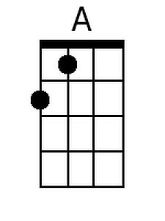 | Bari |  |  |  | 