**Marine’s Hymn (Jacques Offenbach) Key C**

**C G C**

From the Halls of Montezu - ma,

**G G7 C**

To the shores of Tripoli

**G C**

We fight our country's bat-tles,

**G G7 C**

In the air, on land, and sea

**F C**

First to fight for right and freedom,

**F C**

And to keep our honor clean

**G C**

We are p roud to claim the title,

**G G7 C**

Of Unite d States Marine.

**C G C**

Our flag's unfurled to every breeze,

**G G7 C**

From dawn to setting sun

**G C**

We have fought in ev’ry clime and place,

**G G7 C**

Where we could take a gun

**F C**

In the snow of far-off Northern lands,

**F C**

**BARITONE**

And in sunny tropic scenes

**G C**

You will find us always on the job,

**G G7 C**

The United States Marines.

**C G C**

Here's health to you and to our Corps,

**G G7 C**

Which we are proud to serve

**G C**

In many a strife we've fought for life,

**G G7 C**

And never lost our nerve

**F C**

If the Army and the Navy,

**F C**

Ever look on Heaven’s scenes

**G C**

They will find the streets are guarded,

**G G7 C**

by United States Marines.



C

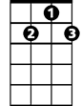

G7

F



G

C



G



F

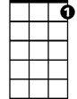

G7

**Marine’s Hymn (Jacques Offenbach) Key D**

**D A D**

From the Halls of Montezu - ma,

**A A7 D**

To the shores of Tripoli

**A D**

We fight our country's bat-tles,

**A A7 D**

In the air, on land, and sea

**G D**

First to fight for right and freedom,

**G D**

And to keep our honor clean

**A D**

We are proud to claim the title,

**A A7 D**

Of United States Marine.

**D A D**

Our flag's unfurled to every breeze,

**A A7 D**

From dawn to setting sun

**A D**

We have fought in ev’ry clime and place,

**A A7 D**

Where we could take a gun

**G D**

In the snow of far-off Northern lands,

**BARITONE**

**G D**

And in sunny tropic scenes

**A D**

You will find us always on the job,

**A A7 D**

The United States Marines.

**D A D**

Here's health to you and to our Corps,

**A A7 D**

Which we are proud to serve

**A D**

In many a strife we've fought for life,

**A A7 D**

And never lost our nerve

**G D**

If the Army and the Navy,

**G D**

Ever look on Heaven’s scenes

**A D**

They will find the streets are guarded,

**A A7 D**

by United States Marines.

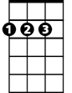

D

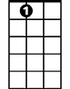

A7



G

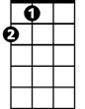

A

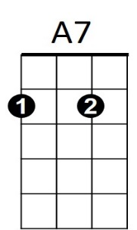



D



A



G

**Marine’s Hymn (Jacques Offenbach) Key G**

**G D G**

From the Halls of Montezu - ma,

**D D7 G**

To the shores of Tripoli

**D G**

We fight our country's bat-tles,

**D D7 G**

In the air, on land, and sea

**C G**

First to fight for right and freedom,

**C G**

And to keep our honor clean

**D G**

We are proud to claim the title,

**D D7 G**

Of United States Marine.

**G D G**



G

Our flag's unfurled to every breeze,

**D D7 G**

From dawn to setting sun

**D G**

We have fought in ev’ry clime and place,

**D D7 G**

Where we could take a gun

**C G**

In the snow of far-off Northern lands,

**C G**



G

And in sunny tropic scenes

**D G**

You will find us always on the job,

**D D7 G**

The United States Marines.

**G D G**

Here's health to you and to our Corps,

**D D7 G**

Which we are proud to serve

**D G**

In many a strife we've fought for life,

**D D7 G**

And never lost our nerve

**C G**

If the Army and the Navy,

**C G**

Ever look on Heaven’s scenes

**D G**

They will find the streets are guarded,

**D D7 G**

by United States Marines.

**BARITONE**

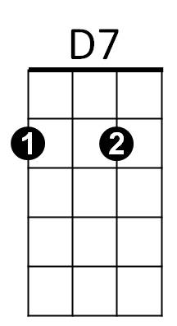



C



D



D7



D

C

