**Martha My Dear (Lennon / McCartney)**

**Intro: verse melody**

**C Am7 Em D C**

Martha my dear though I spend my days in conver-sa-tion

**D G**



G

Em

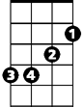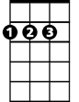

D



C

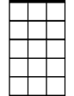

Am7

Please remember me

**F G7 F G**

Martha, my love don't forget me

**F G G F G**

Martha, my dear

**Bm Em D**

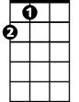

A

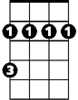

Bm

F

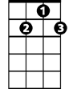

G7

Hold your head up, you silly girl, look what you've done

**A Em**

When you find yourself in the thick of it,

**A Em F#m Bm**

Help yourself to a bit of what is all a-round you,

**Bm Em Em7**

You silly girl

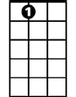

A7

Em7

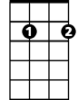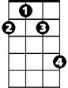

F#m

**B** **m Em**

Take a good look around you

**Bm Em A7**

Take a good look an d you’re bound to see, that you and me

**G Bm Em Em7**

Were mea nt to be with each other, you silly girl

**BARITONE**

**Instrumental verse**

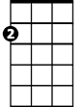

Em



D

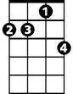

Am7

C



**Bm Em D**

Hold your head up, you silly girl, see what you've done

**A Em**

When you find yourself in the thick of it,

**A Em F#m Bm**

Help yourself to a bit of what is all a-round you,

**Bm Em Em7**

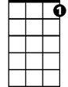

G7



G



F

You silly girl

**C Am7 Em D C**

Martha, my dear, you have always been my inspi – ra-tion

**D G**

Please, be good to me,

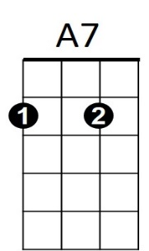**F G7 F G**



Em7



F#m



A

Bm



Martha, my love don't forget me

**F G G F G C**

Martha, my dear