Mary, Did You Know?
Lyrics by Mark Lowry & music by Buddy Greene (1991)
Keys of Am, Dm & Em
"Mary, Did You Know?" is a Christmas song with lyrics written by Mark Lowry (born June 24, 1958 and a member of the Gaither Vocal Band from 1988 to 2002 and 2009-2013) and music written by Buddy Greene (born October 30, 1953). It was originally recorded by Christian recording artist Michael English (born April 12, 1962 and a member if the Gaither Vocal Band from 1985–94 and 2009–13) on his self-titled debut solo album in 1991. It reached No. 6 on CCM Magazine's AC Chart. Lowry would record the song several times himself, most notably with the Gaither Vocal Band on their 1998 Christmas album "Still the Greatest Story Ever Told."
The song has since gone on to become a modern Christmas classic, being recorded by many artists over the years across multiple genres.
"Mary, Did You Know?" is originally in the key of E♭ minor (3 flats), with a tempo of 53 beats per minute based around a chord progression of E♭m–D♭–A♭m–B♭7sus4–B♭7 [ i VII iv V ] and is in the 4/4 meter.
A duet version recorded by Wynonna Judd and Kenny Rogers on Rogers' holiday album "The Gift" peaked at No. 55 on the Billboard Hot Country Singles & Tracks chart in 1997.
Criticism.
"Mary, Did You Know?" remains a popular piece of Christmas music, although some criticize it for what they perceive as a lack of scriptural or theological depth. For example, Lutheran writer Holly Scheer, in addressing the rhetorical-question title of the song writes that those familiar with "the biblical account of Christ’s conception and birth shouldn’t need to ask if Mary knew, because the Bible plainly tells us she did."
On the other hand the Roman Catholic author Karl Erickson implored people to praise "Mary, Did You Know?" as a "beautiful expression of God’s love for all of us" and responded to criticism of the piece, stating that "Mary, Did You Know is a song and not a theological essay. Even as simple Christmas music, however, it does a fine job conveying the beauty and profound mystery of the Incarnation. Yes, there is some poetic license taken within the lyrics, but much less than is taken within innumerable other songs we are asked to sing regularly—Sing a New Church, for example."
Source: Wikipedia, https://en.wikipedia.org/wiki/Mary,_Did_You_Know

Note: In all versions, the introduction can be extended to, for example, the last two lines of the first verse, etc.

At YouTube –
- Mark Lowry: https://www.youtube.com/watch?v=bXmfkFoX-PE
- Wynonna Judd & Kenny Rogers: https://www.youtube.com/watch?v=mN70R-3ao0U
- Clay Aiken: https://www.youtube.com/watch?v=_srtfgf2gqQ
Mary, Did You Know?
Lyrics by Mark Lowry & Music by Buddy Greene (1991)
Key of Am
As performed by Mark Lowry
https://www.youtube.com/watch?v=bXmfkFoX-PE

GCEA  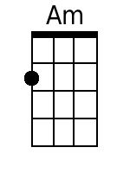  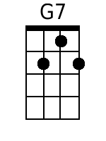  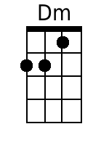  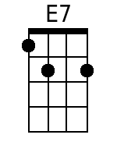  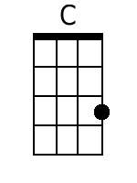  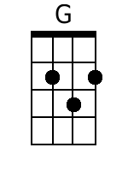  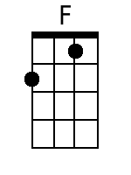 | Introduction: Am  Am G7  Mary, did you know that your Baby Boy  Dm E7  Would one day walk on water?  Am G7  Mary, did you know that your Baby Boy  Dm E7  Would save our sons and daughters?  Dm G7  Did you know that your Baby Boy  C G Am G  Has come to make you new?  Dm  The Child that you delivered  E7  Will soon deliver you.  Am G7  Mary, did you know that your Baby Boy  Dm E7  Will give sight to a blind man?  Am G7  Mary, did you know that your Baby Boy  Dm E7  Will calm the storm with His hand?  Dm G7  Did you know that your Baby Boy  C G Am G  Has walked where angels trod?  Dm  When you kiss your little Baby  E7  You kissed the face of God?  Bridge  F  The blind will see.  G  The deaf will hear.  Am F  The dead will live again.  Dm  The lame will leap.  E7  The dumb will speak  Am E7  The praises of The Lamb.  Am G7  Mary, did you know that your Baby Boy  Dm E7  Is Lord of all creation?  Am G7  Mary, did you know that your Baby Boy  Dm E7  Would one day rule the nations?  Dm G7  Did you know that your Baby Boy  C G Am G  Is heaven's perfect Lamb?  Dm  The sleeping Child you're holding  E7 Am  Is the great "I am" | Bari  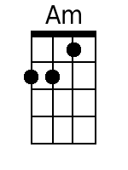  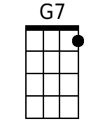  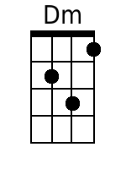  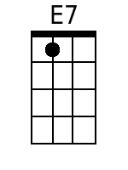  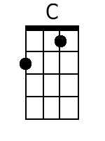  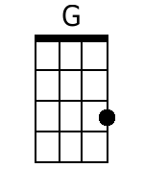  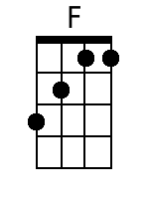

Mary, Did You Know?
Lyrics by Mark Lowry & Music by Buddy Greene (1991)
Key of Am
As performed by Kenny Rogers and Wynonna Judd
https://www.youtube.com/watch?v=mN70R-3ao0U

GCEA | Introduction: Am  Am G7  Mary, did you know that your Baby Boy  Dm E7  Would one day walk on water?  Am G7  Mary, did you know that your Baby Boy  Dm E7  Would save our sons and daughters?  Dm G7  Did you know that your Baby Boy  C G Am G  Has come to make you new?  Dm  The Child that you delivered  E7  Will soon deliver you.  Am G7  Mary, did you know that your Baby Boy  Dm E7  Will give sight to a blind man?  Am G7  Mary, did you know that your Baby Boy  Dm E7  Will calm the storm with His hand?  Dm G7  Did you know that your Baby Boy  C G Am G  Has walked where angels trod?  Dm  When you kiss your little Baby  E7  You kissed the face of God?  Am C Dm E7  Ohh.. Mary did you know.. ….  Am C Dm E7  Ooo ..Mary did you know.. …. …  Bridge  F  The blind will see.  G  The deaf will hear.  Am F  The dead will live again.  Dm  The lame will leap.  E7  The dumb will speak  Am E7  The praises of The Lamb.  Am G7  Mary, did you know that your Baby Boy  Dm E7  Is Lord of all creation?  Am G7  Mary, did you know that your Baby Boy  Dm E7  Would one day rule the nations?  Dm G7  Did you know that your Baby Boy  C G Am G  Is heaven's perfect Lamb?  Dm  The sleeping Child you're holding  E7 Am G7 Dm E7  Is the great "I am"  Outro:  Am G7 Dm E7  Mary . . .  Am G7 Dm E7  Mary did you know ?  Am G7 Dm E7  Am  Mary did you know,  G7 Dm E7 Am [Hold]  That your baby boy ? | Bari

Mary, Did You Know?
Lyrics by Mark Lowry & Music by Buddy Greene (1991)
Key of Dm

GCEA  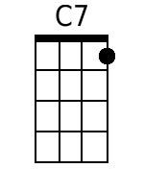  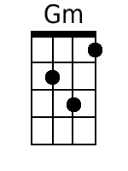  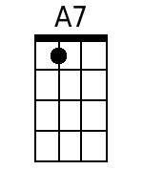  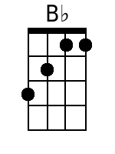 | Introduction: Dm  Dm C7  Mary, did you know that your Baby Boy  Gm A7  Would one day walk on water?  Dm C7  Mary, did you know that your Baby Boy  Gm A7  Would save our sons and daughters?  Gm C7  Did you know that your Baby Boy  F C Dm C  Has come to make you new?  Gm  The Child that you delivered  A7  Will soon deliver you.  Dm C7  Mary, did you know that your Baby Boy  Gm A7  Will give sight to a blind man?  Dm C7  Mary, did you know that your Baby Boy  Gm A7  Will calm the storm with His hand?  Gm C7  Did you know that your Baby Boy  F C Dm C  Has walked where angels trod?  Gm  When you kiss your little Baby  A7  You kissed the face of God?  Bridge  B♭  The blind will see.  C  The deaf will hear.  Dm B♭  The dead will live again.  Gm  The lame will leap.  A7  The dumb will speak  Dm A7  The praises of The Lamb.  Dm C7  Mary, did you know that your Baby Boy  Gm A7  Is Lord of all creation?  Dm C7  Mary, did you know that your Baby Boy  Gm A7  Would one day rule the nations?  Gm C7  Did you know that your Baby Boy  F C Dm C  Is heaven's perfect Lamb?  Gm  The sleeping Child you're holding  A7 Dm  Is the great "I am" | Bari  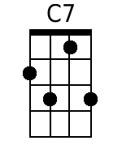  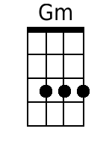  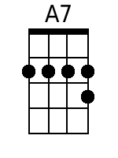  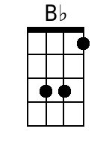

Mary, Did You Know?
Lyrics by Mark Lowry & music by Buddy Greene (1991)
Key of Em

GCEA  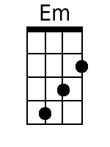  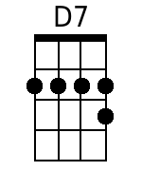  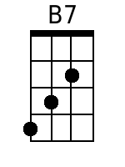  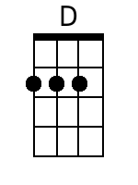 | Introduction: Em  Em D7  Mary, did you know that your Baby Boy  Am B7  Would one day walk on water?  Em D7  Mary, did you know that your Baby Boy  Am B7  Would save our sons and daughters?  Am D7  Did you know that your Baby Boy  G D Em D  Has come to make you new?  Am  The Child that you delivered  B7  Will soon deliver you.  Em D7  Mary, did you know that your Baby Boy  Am B7  Will give sight to a blind man?  Em D7  Mary, did you know that your Baby Boy  Am B7  Will calm the storm with His hand?  Am D7  Did you know that your Baby Boy  G D Em D  Has walked where angels trod?  Am  When you kiss your little Baby  B7  You kissed the face of God?  Bridge  C  The blind will see.  D  The deaf will hear.  Em C  The dead will live again.  Am  The lame will leap.  B7  The dumb will speak  Em B7  The praises of The Lamb.  Em D7  Mary, did you know that your Baby Boy  Am B7  Is Lord of all creation?  Em D7  Mary, did you know that your Baby Boy  Am B7  Would one day rule the nations?  Am D7  Did you know that your Baby Boy  G D Em D  Is heaven's perfect Lamb?  Am  The sleeping Child you're holding  B7 Em  Is the great "I am" | Bari  