**Maverick Theme Song (David Buttolph / Paul Francis Webster)**

**C F**

Who is the tall dark stranger there

**C F C**

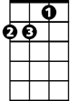

Dm

F



C

Maverick is the name

**Dm**

Ridin the trail to who knows where

**G C G**

Luck is his companion

**C G C**

Gamblin is his game

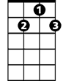

G7



G

**C F**

Smooth as a handle on a gun

**C F C**

Maverick is the name

**Dm**

Wild as the wind in Oregon

**G C G**

Blowin up a can - yon

**C G C**

Easier to tame

**BARITONE**

**F C**

Riverboat ring your bell

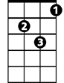

Dm



F

C



**F C**

Fare thee well Annabel

**F G C G7**

Luck is the lady that he loves the best

**G G7**

Natchez to New Orleans

**G G7**

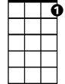

G7



G

Livin on jacks and queens

**G F C**

Maverick is a legend of the west

**F C**

Riverboat ring your bell

**F C**

Fare thee well Annabel

**F G C G7**

Luck is the lady that he loves the best

**G G7**

Natchez to New Orleans

**G G7**

Livin on jacks and queens

**G F C**

Maverick is a legend of the west

**G F C**

Maverick is a legend of the west