Maxwell’s Silver Hammer (Lennon & McCartney, 1969) (C)
Maxwell’s Silver Hammer by The Beatles (D)

Intro (single strum to get the pitch) C  C A7 Dm  Joan was quizzical studied pataphysical science in the home.  G7 C G7  Late nights all alone with a test tube, oh, oh-oh-oh.  C A7 Dm  Maxwell Edison majoring in medicine calls her on the phone.  G7 C G7  Can I take you out to the pictures Jo-o-o-oan?  D7 G7  But, as she's getting ready to go, a knock comes on the door.  Chorus  C D7  Bang! Bang! Maxwell's silver hammer came down upon her head.  G7 Dm G7 C G7 C  Clang! Clang! Maxwell's silver hammer made sure that she was dead.  Instrumental | C E | Am C | F | C |  C A7 Dm  Back in school again, Maxwell plays the fool again, Teacher gets annoyed.  G7 C G7  Wishing to avoid an unpleasant sce-e-e-ene.  C A7 Dm  She tells Max to stay when the class has gone away, so, he waits behind.  G7 C G7  Writing fifty times “I must not be so-o-o-o.”  D7 G7  But, when she turns her back on the boy, he creeps up from behind. Chorus  C A7 Dm  P.C. Thirty-one said “we caught a dirty one,” Maxwell stands alone.  G7 C G7  Painting testimonial pictures oh, oh-oh-oh.  C A7 Dm  Rose and Valerie, screaming from the gallery, say he must go free!  G7 C G7  The judge does not agree, and he tells them so-o-o-o.  D7 G7  But, as the words are leaving his lips, a noise comes from behind.  C D7  Bang! Bang! Maxwell's silver hammer came down upon his head.  G7 Dm G7 C  Clang! Clang! Maxwell's silver hammer made sure that he was dead.  | C E | Am C | F | C | C E | Am C | F | C  Sil - ver Ham – mer. | 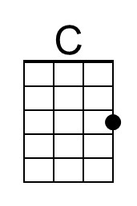 | 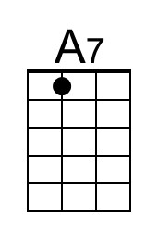
 | 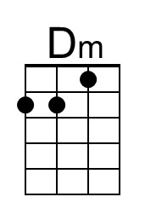 | 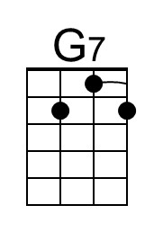
 | 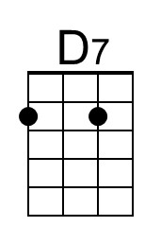 | 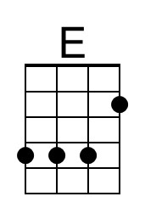
 | 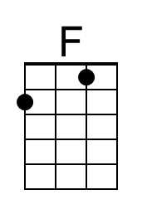
 | 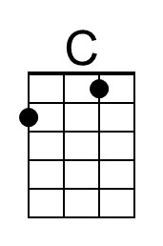 | 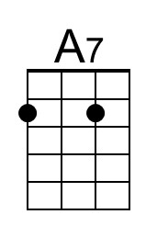
 | 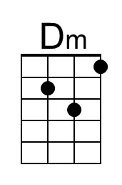 | 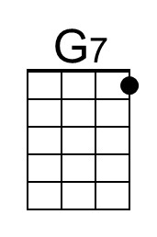
 | 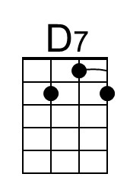 | 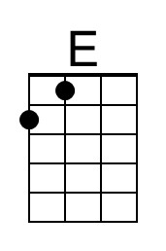
 | 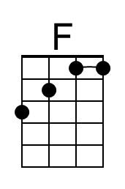

Maxwell’s Silver Hammer (Lennon & McCartney, 1969) (G)
Maxwell’s Silver Hammer by The Beatles (D)

Intro (single strum to get the pitch) G  G E7 Am  Joan was quizzical studied pataphysical science in the home.  D7 G D7  Late nights all alone with a test tube, oh, oh-oh-oh.  G E7 Am  Maxwell Edison majoring in medicine calls her on the phone.  D7 G D7  Can I take you out to the pictures Jo-o-o-oan?  A7 D7  But, as she's getting ready to go, a knock comes on the door.  Chorus  G A7  Bang! Bang! Maxwell's silver hammer came down upon her head.  D7 Am D7 G D7 G  Clang! Clang! Maxwell's silver hammer made sure that she was dead.  Instrumental | G B | Em G | C | G |  G E7 Am  Back in school again, Maxwell plays the fool again, Teacher gets annoyed.  D7 G D7  Wishing to avoid an unpleasant sce-e-e-ene.  G E7 Am  She tells Max to stay when the class has gone away, so, he waits behind.  D7 G D7  Writing fifty times “I must not be so-o-o-o.”  A7 D7  But, when she turns her back on the boy, he creeps up from behind. Chorus  G E7 Am  P.C. Thirty-one said “we caught a dirty one,” Maxwell stands alone.  D7 G D7  Painting testimonial pictures oh, oh-oh-oh.  G E7 Am  Rose and Valerie, screaming from the gallery, say he must go free!  D7 G D7  The judge does not agree, and he tells them so-o-o-o.  A7 D7  But, as the words are leaving his lips, a noise comes from behind.  G A7  Bang! Bang! Maxwell's silver hammer came down upon his head.  D7 Am D7 G  Clang! Clang! Maxwell's silver hammer made sure that he was dead.  | G B | Em G | C | G | G B | Em G | C | G  Sil - ver Ham – mer. | 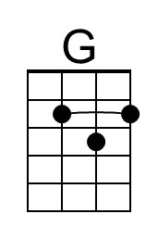 | 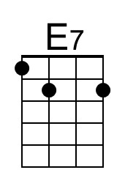
 | 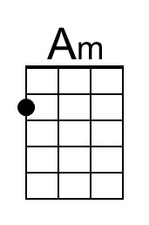
 |  | 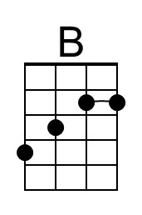
 | 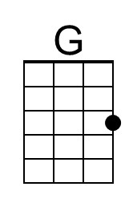 | 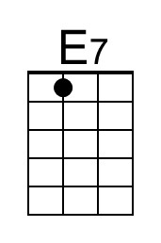
 | 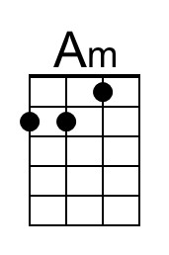
 |  | 