**Maxwell’s Silver Hammer (Paul McCartney, John Lennon)**

**C A7**

Joan was quizzical studied pataphysical

**Dm**

Science in the home

**G7 C G7**

Late nights all alone with a test tube oh oh oh oh

**C A7**

Maxwell Edison majoring in medicine

**Dm**

Calls her on the phone

**G7 C G7**

Can I take you out to the pictures Jo-o-o-oan

**D7**

But as she's getting ready to go

**G7 Gdim G7**

A knock comes on the door

**Chorus:**

**C**

Bang Bang Maxwell's silver hammer

**D7**

Came down upon her head

**G7**

Bang bang Maxwell's silver hammer

**Dm G7 C G7 C**

Made sure that she was dead

**C/ E7/ Am/ C7/ F// G7// C/ G7/ C/**

**C A7**

Back in school again Maxwell plays the fool again

**Dm**

Teacher gets annoyed

**G7 C G7**

Wishing to avoid an unpleasant sce e e ene

**C A7**

She tells Max to stay when the class has gone away

**Dm**

So he waits behind

**G7 C G7**

Writing fifty times I must not be so o o o

**D7**

But when she turns her back on the boy

**G7 Gdim G7**

He creeps up from behind

**(Chorus)**

**(Instrumental Chorus)**

**C/ E7/ Am/ C7/ F/ G7/ C/ G7/ C/**

**C A7**

P.C. Thirty-one said we caught a dirty one

**Dm**

Maxwell stands alone

**G7 C G7**

Painting testimonial pictures oh oh oh oh

**C A7**

Rose and Valerie screaming from the gallery

**Dm**

Say he must go free

**G7 C G7**

The judge does not agree and he tells them so-o-o-o

**D7**

But as the words are leaving his lips

**G7 Gdim G7**

A noise comes from behind

**(Chorus)**

**(Instrumental Chorus)**

**C E7 Am C7 F// G7// C/ G7/ C/**

Sil - ver Ham - mer

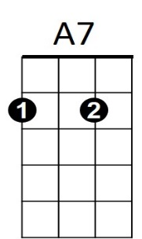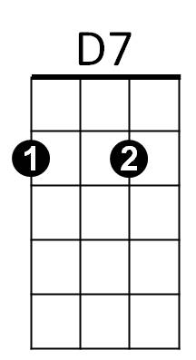



F

**BARITONE**

C

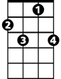

C7

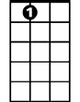

E7

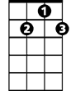

D7

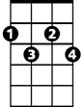

Gdim

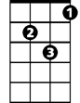

Dm

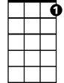

G7



C

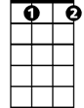

Gdim



G7

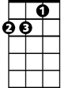

Dm



A7

F



C7

E7

