**May Day is Lei Day in Hawaii**

**VAMP: G7 C7 F 2X**

F

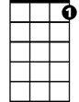

C7

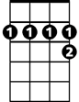

D7

**F C7**

May Day is Lei Day in Hawaii

**F**

Garlands of flowers everywhere

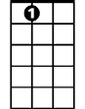

A7

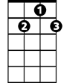

G7

**D7 G7**

All of the colors in the rainbow

**C7**

Maidens with blossoms in their hair

**F C7**

Flowers that mean we should be happy

**F A7**

Throwing aside a load of care - Oh

**D7 G7**

May Day is Lei Day in Hawaii

**C7 F**

**BARITONE**



D7



F

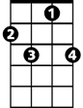

C7

Lei Day is happy days out here

**VAMP 2x**

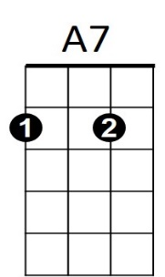**(REPEAT SONG)**



G7