May The Bird Of Paradise Fly Up Your Nose (Neal Merritt, 1965)
May The Bird Of Paradise Fly Up Your Nose by Little Jimmy Dickens, The Bobby Lord Show, Oct. 19, 1965 – Key of C

Intro (4 measures) C | Dm G7 | C | C  C G7 C  One fine day as I was walking down the street,  G7  Spied a beggar man with rags upon his feet  C C7 F Fm  Took a penny from my pocket, in his tin cup I did drop it.  C G7 C  And I heard him say as I made my re-treat.  Chorus  C G7 C  May the bird of paradise fly up your nose,  G7  May an elephant caress you with his toes.  C C7 F  May your wife be plagued with runners in her hose,  C G7 C - G7  May the bird of para-dise fly up your nose  C G7 C G7  My laundry man is really on his toes, found a hundred dollar bill among my clothes  C C7 F Fm  When he called me I came running, gave him back his dime for phoning  C G7 C  And I heard him saying as I turned to go. Chorus  C G7 C  I was way behind one day to catch the train.  G7  The taxi driver said “We'll make it just the same.”  C C7 F Fm  A speed cop made it with us, and as he wrote out the ticket  C G7 C  I stood by politely waiting for my change. Chorus  Outro  C G7 C | G7 | C  May the bird of paradise fly up your nose. |  |  |  |  |  |  |  | 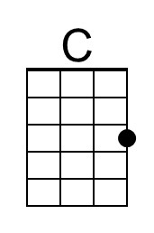
 |  |  |  |  |  |  |  | 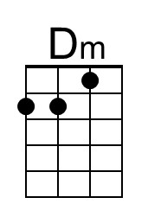
 |  |  |  |  |  |  |  | 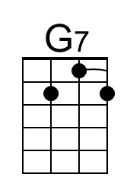
 |  |  |  |  |  |  |  | 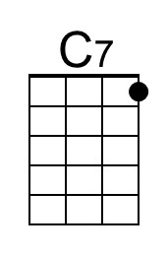
 |  |  |  |  |  |  |  | 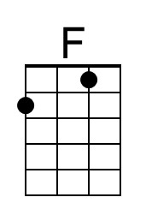
 |  |  |  |  |  |  |  | 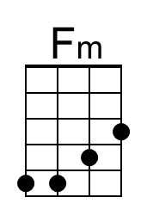
 |  | Bari | 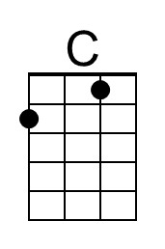 | 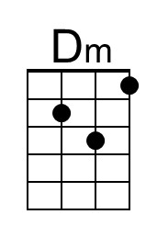 | 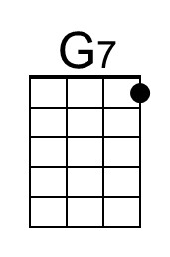 | 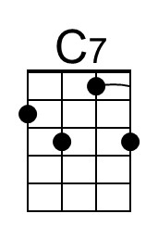 | 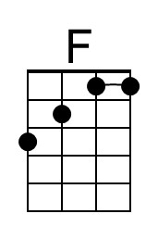 | 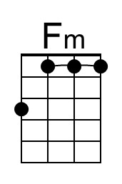

May The Bird Of Paradise Fly Up Your Nose (Neal Merritt, 1965)
May The Bird Of Paradise Fly Up Your Nose by Little Jimmy Dickens, The Bobby Lord Show, Oct. 19, 1965 – Key of G

Intro (4 measures) G | Am D7 | G | G  G D7 G  One fine day as I was walking down the street,  D7  Spied a beggar man with rags upon his feet  G G7 C Cm  Took a penny from my pocket, in his tin cup I did drop it.  G D7 G  And I heard him say as I made my re-treat.  Chorus  G D7 G  May the bird of paradise fly up your nose,  D7  May an elephant caress you with his toes.  G G7 C  May your wife be plagued with runners in her hose,  G D7 G - D7  May the bird of para-dise fly up your nose  G D7 G D7  My laundry man is really on his toes, found a hundred dollar bill among my clothes  G G7 C Cm  When he called me I came running, gave him back his dime for phoning  G D7 G  And I heard him saying as I turned to go. Chorus  G D7 G  I was way behind one day to catch the train.  D7  The taxi driver said "We'll make it just the same."  G G7 C Cm  A speed cop made it with us, and as he wrote out the ticket  G D7 G  I stood by politely waiting for my change. Chorus  Outro  G D7 G | D7 | G  May the bird of paradise fly up your nose. |  |  |  |  |  |  |  | 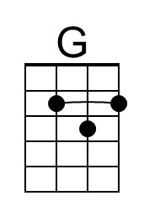
 |  |  |  |  |  |  |  | 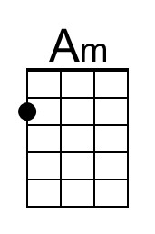
 |  |  |  |  |  |  |  | 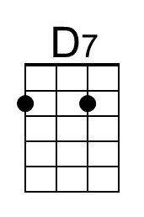
 |  |  |  |  |  |  |  | 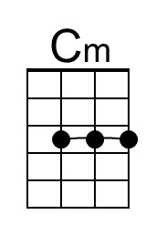
 |  | Bari | 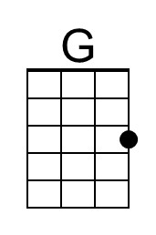 | 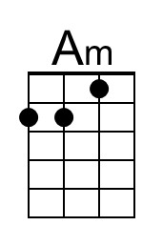 | 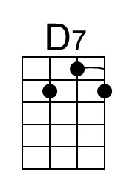 |  |  | 