
Mele Kalikimaka
C14 C
(R. Alex Anderson, 1949) – Mele Kalikimaka by Bing Crosby & The Andrews Sisters (1950)

Starting Note: G  Intro (Last 2 lines) C | C7 A7 | Dm G7 | C | G7 |  C  Mele Kalikimaka is the thing to say  G  On a bright Hawaiian Christmas Day  G7  That's the island greeting that we send to you  Dm C  From the land where palm trees sway  C7 F  Here we know that Christmas will be green and bright  A7 D7 G7  The sun will shine by day and all the stars by night  C C7 A7  Mele Kalikimaka is Ha-waii's way  ___________________________________________  │ Dm G7 C  │ 1. To say Merry Christmas to you. (Repeat from Top)  ___________________________________________  │ Dm G7 Dm G7  │ 2. To say Merry Christmas, a very Merry Christmas  │ Dm G7 C (Hold)  │ To say Merry Christmas to you. |  |  |  |  |  |  |  | 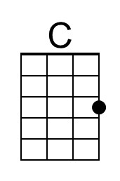
 |  |  |  |  |  |  |  | 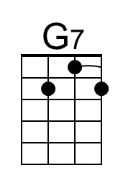
 |  |  |  |  |  |  |  | 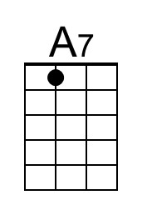
 |  |  |  |  |  |  |  | 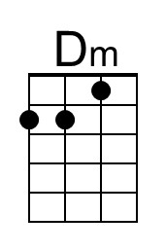
 |  |  |  |  |  |  |  | 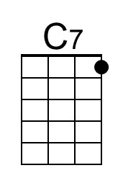
 |  |  |  |  |  |  |  | 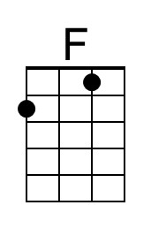
 |  |  |  |  |  |  |  | 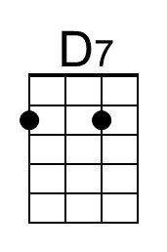
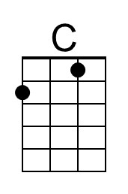 | 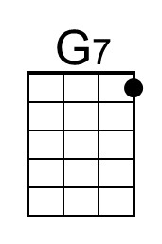 | 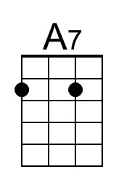 | 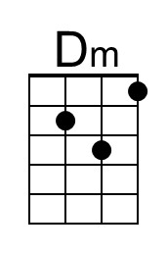 | 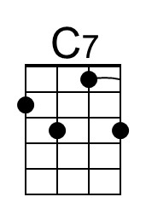 | 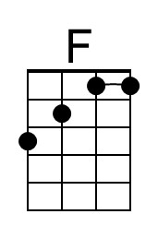 | 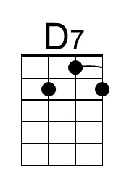 | 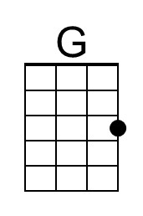 | 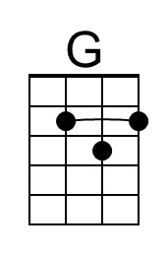

Mele Kalikimaka
C14 G
(R. Alex Anderson, 1949) – Mele Kalikimaka by Bing Crosby & The Andrews Sisters (1950)

Starting Note: D

Intro (Last 2 lines) G | G7 E7 | Am D7 | G | D7 |

G
Mele Kalikimaka is the thing to say
D
On a bright Hawaiian Christmas Day
D7
That's the island greeting that we send to you
Am G
From the land where palm trees sway
G7 C
Here we know that Christmas will be green and bright
E7 A7 D7
The sun will shine by day and all the stars by night
G G7 E7
Mele Kalikimaka is Ha-waii's way
___________________________________________
│ Am D7 G
│ 1. To say Merry Christmas to you. (Repeat from Top)
___________________________________________
│ Am D7 Am D7
│ 2. To say Merry Christmas, a very Merry Christmas
│ Am D7 G (Hold)
│ To say Merry Christmas to you.

 |  |  |  |  |  |  |  | 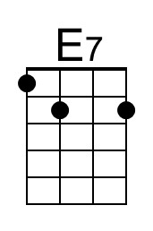
 |  |  |  |  |  |  |  | 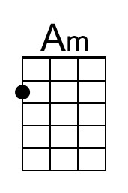
 |  | 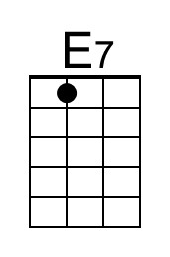 | 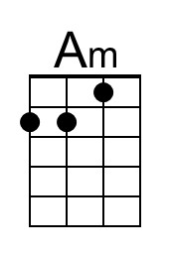 |  |  |  | 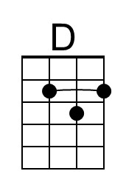 | 