**Mele Kalikimaka (R. Alex Anderson)**

C14 C

**Key C – Starting Note: G**

**C**

Mele Kalikimaka is the thing to say

**G**

On a bright Hawaiian Christmas Day

**G7**

That's the island greeting that we send to you

**Dm C**

From the land where palm trees sway

**C7 F**

Here we know that Christmas will be green and bright

**A7 D7 G7**

The sun will shine by day and all the stars by night

**C C7 A7**

Mele Kalikimaka is Hawaii's way

**Dm G7 C**

To say Merry Christmas to you

**(Repeat entire song; replace last line with ending)**

**Dm G7 Dm G7**

To say Merry Christmas, a very Merry Christmas

**Dm G7 C**

To say Merry Christmas to you

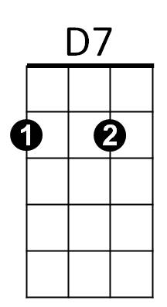



G

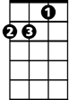

Dm

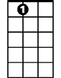

A7

F

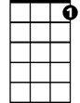

C7



C

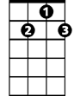

G7

**BARITONE**

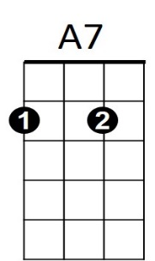



G

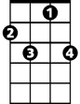

C7



F

C



G7



D7

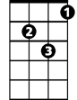

Dm

**Mele Kalikimaka (R. Alex Anderson)**

C14 G

**Key G - Starting Note: D**

**G**

Mele Kalikimaka is the thing to say

**D**

On a bright Hawaiian Christmas Day

**D7**

That's the island greeting that we send to you

**Am G**

From the land where palm trees sway

**G7 C**

Here we know that Christmas will be green and bright

**E7 A7 D7**

The sun will shine by day and all the stars by night

**G G7 E7**

Mele Kalikimaka is Hawaii's way

**Am D7 G**

To say Merry Christmas to you

**(Repeat entire song; replace last line with ending)**

**Am D7 Am D7**

To say Merry Christmas, a very Merry Christmas

**Am D7 G**

To say Merry Christmas to you





G



C

E7

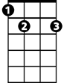

G7

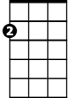

Am



A7

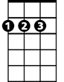

D



**BARITONE**



D

C



E7



Am



D7



G7



G