Mellow Yellow (Donovan Leitch) (G)

G C  I'm just mad about Saffron  G D7 D C#  Saffron's mad about me  C C7  I'm just mad about Saffron  D  She's just mad about me  Chorus:  D7 G C  They call me mellow yellow (Quite rightly)  D7 G C  They call me mellow yellow (Quite rightly)  D7 G C D7  They call me mellow yellow  G C  I'm just mad about Fourteen  G D7 D C#  Fourteen's mad about me  C C7  I'm just mad about Fourteen  D  She's just mad about me (Chorus)  G C  Born high forever to fly  G D7 D C#  Wind ve-locity nil  C C7  Wanna high forever to fly  D  If you want your cup our fill (Chorus) |  |  |  | G C  E-lec-trical banana  G D7 D C#  Is gonna be a sudden craze  C C7  E-lec-trical banana  D  Is bound to be the very next phase  (Chorus)  G C  Saffron, yeah  G D7 D C#  I'm just mad about her  C C7  I'm just mad about Saffron  D  She's just mad about me. (Chorus) |  |  |  | 
 |  |  |  |  |  |  |  | 
 |  |  |  |  |  |  |  | 
 |  |  |  |  |  |  |  | 
 |  |  |  |  |  |  |  | 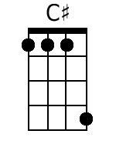
 |  |  |  |  |  |  |  | 
Bari
 |  |  |  |  | 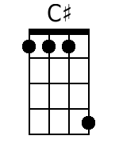 | 

