**Mellow Yellow (Donovan Leitch)**

**C F**

I'm just mad about Saffron

**C G7 G Gb**

Saffron's mad about me

**F F7**

I'm just mad about Saffron

**G**

She's just mad about me

**Chorus:**

**G7 C F**

They call me mellow yellow (Quite rightly)

**G7 C F**

T hey call me mellow yellow (Quite rightly)

**G7 C F G7**

They call me mellow yellow

**C F**

I'm just mad about Fourteen

**C G7 G Gb**

Fourteen's mad about me

**F F7**

I'm just mad about Fourteen

**G**

She's just mad about me

**(Chorus)**

**C F**

Born high forever to fly

**C G7 G Gb**

**BARITONE**

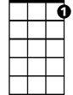

G7



F



G

Wind ve-locity nil

C



**F F7**

Wanna high forever to fly

**G**

If you want your cup our fill

**(Chorus)**

**C F**

E-lec-trical banana

**C G7 G Gb**

Is gonna be a sudden craze

**F F7**

E-lec-trical banana

**G**

Is bound to be the very next phase

**(Chorus)**

**C F**

Saffron, yeah

**C G7 G Gb**

I'm just mad about her

**F F7**

I'm just mad about Saffron

**G**

She's just mad about me

**(Chorus)**

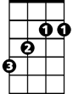

Gb

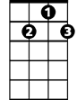

G7

F

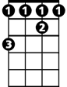

Gb



G



C