**Memory (Andrew Lloyd Webber)**

**C Am**

Midnight, not a sound on the pavement

**F**

Has the moon lost a memory?

**Em**

She is smiling alone

**Dm**

In the lamplight the withered leaves

**Am**

collect at my feet

**G C**

And the wind begins to moan

**C Am**

Memory, all alone in the moonlight

**F**

I can smile at the old days

**Em**

I was beautiful then

**Dm Am**

I remember the time I knew what happiness was

**G C**

Let the memory live again

**Em F Em F**

Every street lamp seems to beat

**Em C G**

A fainter listening warning

**Em D**

Someone mutters and a street lamp flutters

**Em C D**

And soon it will be morning

**C Am**

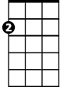

Em

Daylight, I must wait for the sunrise

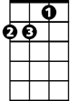

Am

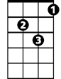

Dm

C



**BARITONE**

**F**

I must think of a new life

**Em**

And I mustn't give in

**Dm**

When the dawn comes



D



F

**Am**

Bm

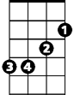

G

Tonight will be a memory too

**G C**

And a new day will begin

**Em F Em F**

Burnt out ends of smoky days

**Em C G**

The stale cold smell of morning

**Em D**

A street lamp dies another night is over

**Em A7 D**

Another day is dawning

**G Em**

Touch me, it's so easy to leave me

**C**

All alone with the memory

**Bm**

Of my days in the sun

**Am**

If you touch me

**Em**

You'll understand what happiness is

**D G**

Look, a new day has begun

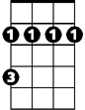

Bm