GCEA Uke  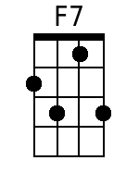          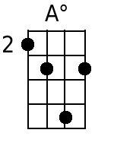  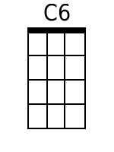     | Mighty Mississippi  By Randy Sparks  Key of C (Original Key of G); Cut Time. “Moderately With A Strong Beat.” GCEA Uke.  From the New Christy Minstrels 1963 album Ramblin'.  Five Measure Introduction.  Chorus:  F7 C - C7  Mighty Mississippi, roll a-long;  F7 C  Lazy river, sing your song.  E7 C A dim  And it's away, Dixie, steady as you go.  C6 D7 G7 - C - C7  On your way down to the Gulf of Mexico.  F7 C - C7  1. Oh! ol' man river keeps on callin' me.  F7 C  There ain't no place on earth I'd rather be  E7 F A dim  Well it's Greenville, Vicksburg and Natchez down the line;  C6 D7 G7 C - C7  It's fare-well ol' Memphis, Ten-nes-see. Oh! Chorus.  F7 C - C7  2. Well, I used to ride aboard that River Queen.  F7 C  It's many a game of fortune I have seen.  E7 F A dim  Oh, once I lost a million and I won it back again.  C6 D7 G7 C - C7  On the way from Baton Rouge to New - Or-leans. Oh!  F7 C - C7  Mighty Mississippi, roll a-long;  F7 C  Lazy river, sing your song.  E7 C A dim  And it's away, Dixie, steady as you go.  C6 D7 G7  On your way down to the Gulf, my honey!  C6 D7 G7 C6 D7 G7 C  Down to the Gulf my baby! Down to the Gulf of Mex-i-co  [Spoken] "One more time!"  C6 D7 G7 C6 (2 Measures)  On your way down to the Gulf of Mex-i-co. [Spoken] Yeah!

