Bari Uke  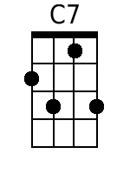  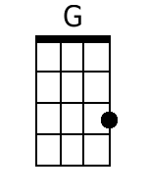  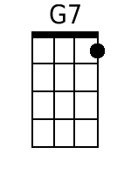  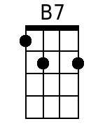  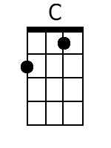  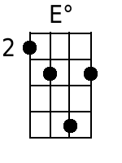  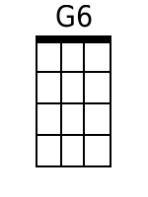  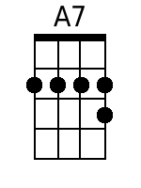  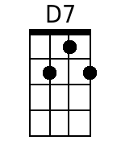 | Mighty Mississippi  By Randy Sparks  Key of G (1 Sharp); Cut Time. “Moderately With A Strong Beat.” Baritone Ukulele.  From the New Christy Minstrels 1963 album Ramblin'.  Five Measure Introduction.  Chorus:  C7 G - G7  Mighty Mississippi, roll a-long;  C7 G  Lazy river, sing your song.  B7 C E dim  And it's away, Dixie, steady as you go.  G6 A7 D7 - G - G7  On your way down to the Gulf of Mexico.  C7 G - G7  1. Oh! ol' man river keeps on callin' me.  C7 G  There ain't no place on earth I'd rather be  B7 C E dim  Well it's Greenville, Vicksburg and Natchez down the line;  G6 A7 D7 G - G7  It's fare-well ol' Memphis, Ten-nes-see. Oh! Chorus.  C7 G - G7  2. Well, I used to ride aboard that River Queen.  C7 G  It's many a game of fortune I have seen.  B7 C E dim  Oh, once I lost a million and I won it back again.  G6 A7 D7 G - G7  On the way from Baton Rouge to New - Or-leans. Oh!  C7 G - G7  Mighty Mississippi, roll a-long;  C7 G  Lazy river, sing your song.  B7 C E dim  And it's away, Dixie, steady as you go.  G6 A7 D7  On your way down to the Gulf, my honey!  G6 A7 D7 G6 A7 D7 G  Down to the Gulf my baby! Down to the Gulf of Mex-i-co  [Spoken] "One more time!"  G6 A7 D7 G6 (2 Measures)  On your way down to the Gulf of Mex-i-co. [Spoken] Yeah!

