**Mister Sandman (Pat Ballard)**

**C7 F E7**

Mister Sandman, bring me a dream

**A7 D7**

Make him the cutest that I've ever seen

**G7 C7**

Give him two lips like roses and clover

**F C#7 C7**

Then tell him that his lonesome nights are over

**C7 F E7**

Mister Sandman, I'm so alone

**A7 D7**

Don't have nobody to call my own

**Gm7 Gm7-5**

Please turn on your magic beam

**F G7 F C7**

Mister Sandman, bring me a dream

**C7 F E7**

Mister Sandman, bring me a dream

**A7 D7**

Make him the cutest that I've ever seen

**G7 C7**

Give him the word that I'm not a rover

**F C#7 C7**

Then tell him that his lonesome nights are over

**C7 F E7**

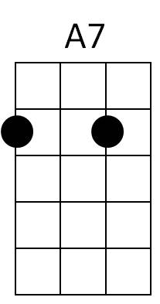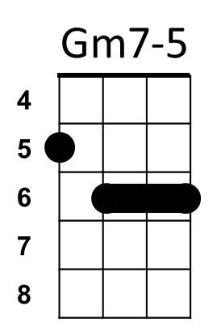Mister Sandman, I'm so alone

**BARITONE**



F

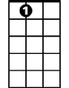

E7

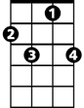

C7

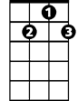

D7

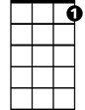

G7

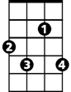

C#7

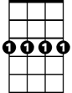

Gm7

**A7 D7**

Don't have nobody to call my own

**Gm7 Gm7-5**

Please turn on your magic beam

**F G7 F C7**

Mister Sandman, bring me a dream

**C7 F E7**

Mister Sandman, yes bring us a dream

**A7 D7**

Give him a pair of eyes with a "come-hither" gleam

**G7 C7**

Give him a lonely heart like Pagliacci

**F C#7 C7**

And lots of wavy hair like Liberace

**C7 F E7**

Mister Sandman, someone to hold

**A7 D7**

Would be so peachy before we're too old

**Gm7 Gm7-5**

Please turn on your magic beam

**F G7**

Mister Sandman,bring us,

**F G7**

Please, please, bring us,

**F G7 F**

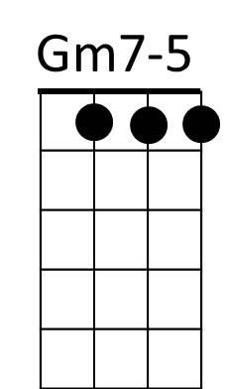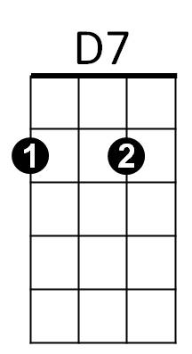Mister Sandman, bring us a dream

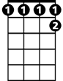

C#7



G7

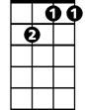

Gm7



A7

F



C7

E7

