Mr Tambourine Man (Bob Dylan, 1964) (G)
Mr. Tambourine Man by The Byrds (1965)

Intro | G Gsus4 | (3x) | G D |  Chorus  C D G C  Hey! Mr. Tambourine Man, play a song for me,  G C D Dsus2 D Dsus2  I'm not sleepy and there ain't no place I'm goin' to.  C D G C  Hey! Mr. Tambourine Man, play a song for me,  G C D G Gsus4 G Gsus4  In the jingle jangle morning, I'll come followin' you.  C D G C  Take me for a trip upon your magic swirlin' ship,  G C  All my senses have been stripped,  G C  And my hands can't feel to grip.  G C  And my toes too numb to step,  G C D Dsus2 D Dsus2  Wait only for my boot heels, to be wanderin'.  C D G C  I'm ready to go anywhere, I'm ready for to fade,  G C  On to my own parade.  G C  Cast your dancin' spell my way,  D Dsus2 D Dsus2  I promise to go under it. Chorus  C D G C  Hey! Mr. Tambourine Man, play a song for me,  G C D Dsus2 D Dsus2  I'm not sleepy and there ain't no place I'm goin' to.  C D G C  Hey! Mr. Tambourine Man, play a song for me,  G C D G  In the jingle jangle morning, I'll come followin' you.  Outro | G Gsus4 | (3x) | G D | G (Hold) | 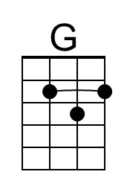 | 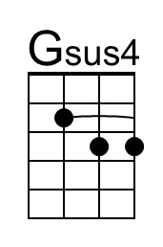
 | 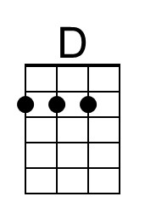 | 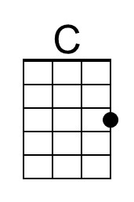
 | 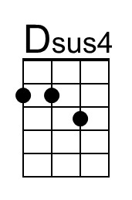 | 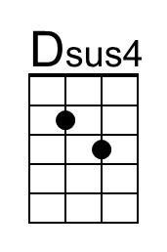
 | Bari
 | 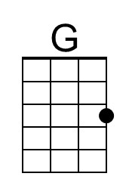 | 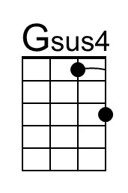
 | 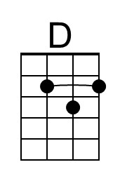 | 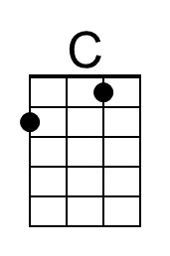
 | 