Mr Tambourine Man (Bob Dylan, 1964) (G)
Mr. Tambourine Man by The Byrds (1965)

Intro | G Gsus4 | (3x) | G D |  Chorus  C D G C  Hey! Mr. Tambourine Man, play a song for me,  G C D Dsus2 D Dsus2  I'm not sleepy and there ain't no place I'm goin' to.  C D G C  Hey! Mr. Tambourine Man, play a song for me,  G C D G Gsus4 G Gsus4  In the jingle jangle morning, I'll come followin' you.  C D G C  Take me for a trip upon your magic swirlin' ship,  G C  All my senses have been stripped,  G C  And my hands can't feel to grip.  G C  And my toes too numb to step,  G C D Dsus2 D Dsus2  Wait only for my boot heels, to be wanderin'.  C D G C  I'm ready to go anywhere, I'm ready for to fade,  G C  On to my own parade.  G C  Cast your dancin' spell my way,  D Dsus2 D Dsus2  I promise to go under it. Chorus  C D G C  Hey! Mr. Tambourine Man, play a song for me,  G C D Dsus2 D Dsus2  I'm not sleepy and there ain't no place I'm goin' to.  C D G C  Hey! Mr. Tambourine Man, play a song for me,  G C D G  In the jingle jangle morning, I'll come followin' you.  Outro | G Gsus4 | (3x) | G D | G (Hold) |  | 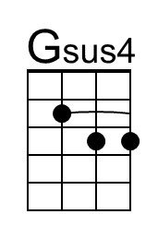
 |  | 
 | 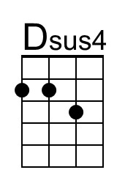 | 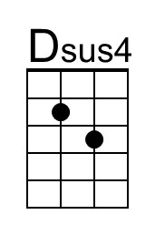
 | Bari
 |  | 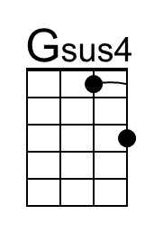
 |  | 
 | 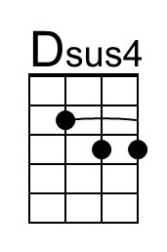

Mr. Tambourine Man (Bob Dylan) Key of D
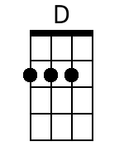
INTRO D A / D A (2x)
CHORUS:
G A D G
Hey! Mr. Tambourine Man, play a song for me,
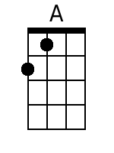
D G A Asus4 A Asus4
I'm not sleepy and there ain't no place I'm goin' to.
G A D G
Hey! Mr. Tambourine Man, play a song for me,
D G A D Dsus2 D Dsus2
In the jingle jangle morning, I'll come followin' you.
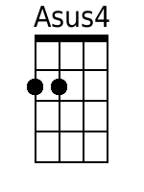
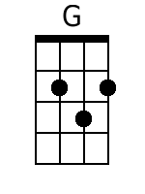
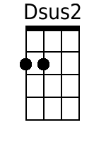
G A D G
Take me for a trip upon your magic swirlin' ship,
D G
All my senses have been stripped,
D G
And my hands can't feel to grip.
D G
BARITONE
And my toes too numb to step,
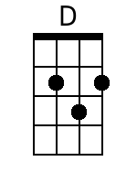
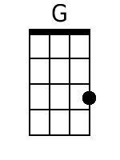
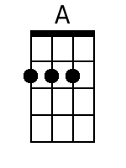
D G A
Wait only for my boot heels, to be wanderin'.

G A D G
I'm ready to go anywhere, I'm ready for to fade,
D G
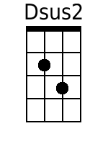
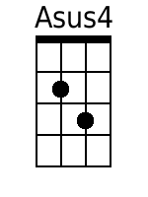
On to my own parade.
D G
Cast your dancin' spell my way,
A
I promise to go under it.

(CHORUS)

G A D G
Hey! Mr. Tambourine Man, play a song for me,
D G A Asus4 A Asus4
I'm not sleepy and there ain't no place I'm goin' to.
G A D G
Hey! Mr. Tambourine Man, play a song for me,
D G A D (Outro) D A / D A (2x) End in D
In the jingle jangle morning, I'll come followin' you.

Mr. Tambourine Man (Bob Dylan) Key of C
INTRO C G / C G (2x)
CHORUS:
F G C F
Hey! Mr. Tambourine Man, play a song for me,
C F G Gsus4 G Gsus4
I'm not sleepy and there ain't no place I'm goin' to.
F G C F
Hey! Mr. Tambourine Man, play a song for me,
C F G C Csus2 C Csus2
In the jingle jangle morning, I'll come followin' you.
F G C F
Take me for a trip upon your magic swirlin' ship,
C F
All my senses have been stripped,
C F
And my hands can't feel to grip.
C F
BARITONE
And my toes too numb to step,
C F G
Wait only for my boot heels, to be wanderin'.

F G C F
I'm ready to go anywhere, I'm ready for to fade,
C F
On to my own parade.
C F
Cast your dancin' spell my way,
G
I promise to go under it.

(CHORUS)

F G C F
Hey! Mr. Tambourine Man, play a song for me,
C F G Gsus4 G Gsus4
I'm not sleepy and there ain't no place I'm goin' to.
F G C F
Hey! Mr. Tambourine Man, play a song for me,
C F G C (Outro) C G / C G (2x) End in C
In the jingle jangle morning, I'll come followin' you.

