**Mr. Tambourine Man (Bob Dylan) Key of G**

|  |
| --- |
| **INTRO G D / G D 2x**  G  **CHORUS:**  **C D G C**  Hey! Mr. Tambourine Man, play a song for me,  **G C D Dsus2 D Dsus2**  D  I'm not sleepy and there ain't no place I'm goin' to.  **C D G C**  Hey! Mr. Tambourine Man, play a song for me,  **G C D G Gsus4 G Gsus4**  In the jingle jangle morning, I'll come followin' you.    C  **C D G C**  Take me for a trip upon your magic swirlin' ship,  **G C**  All my senses have been stripped,  **G C**  And my hands can't feel to grip.  **G C**  And my toes too numb to step,  **BARITONE**  D  G  **G C D**  Wait only for my boot heels, to be wanderin'.  **C D G C**  I'm ready to go anywhere, I'm ready for to fade,  **G C**  C  On to my own parade.  **G C**  Cast your dancin' spell my way,  **D**  I promise to go under it.  **(CHORUS)**  **C D G C**  Hey! Mr. Tambourine Man, play a song for me,  **G C D Dsus2 D Dsus2**  I'm not sleepy and there ain't no place I'm goin' to.  **C D G C**  Hey! Mr. Tambourine Man, play a song for me,  **G C D G (Outro) - G D / G D (2x) end in G**  In the jingle jangle morning, I'll come followin' you. |
|
|
|
|
|
|
|

**Mr. Tambourine Man (Bob Dylan) Key of D**

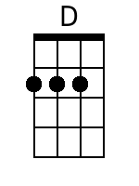**INTRO D A / D A (2x)**

**CHORUS:**

**G A D G**

Hey! Mr. Tambourine Man, play a song for me,

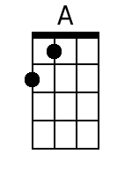 **D G A Asus4 A Asus4**

I'm not sleepy and there ain't no place I'm goin' to.

**G A D G**

Hey! Mr. Tambourine Man, play a song for me,

**D G A D Dsus2 D Dsus2**

In the jingle jangle morning, I'll come followin' you.

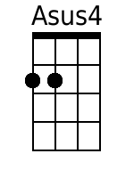

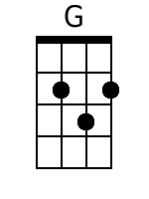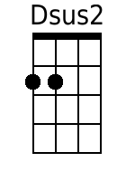**G A D G**

Take me for a trip upon your magic swirlin' ship,

**D G**

All my senses have been stripped,

**D G**

And my hands can't feel to grip.

**D G**

**BARITONE**

And my toes too numb to step,

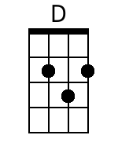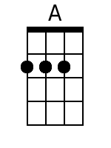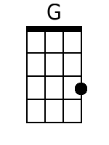 **D G A**

Wait only for my boot heels, to be wanderin'.

**G A D G**

I'm ready to go anywhere, I'm ready for to fade,

**D G**

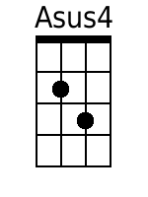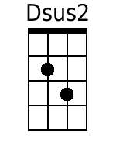On to my own parade.

**D G**

Cast your dancin' spell my way,

**A**

I promise to go under it.

**(CHORUS)**

**G A D G**

Hey! Mr. Tambourine Man, play a song for me,

**D G A Asus4 A Asus4**

I'm not sleepy and there ain't no place I'm goin' to.

**G A D G**

Hey! Mr. Tambourine Man, play a song for me,

**D G A D (Outro) D A / D A (2x) End in D**

In the jingle jangle morning, I'll come followin' you.

**Mr. Tambourine Man (Bob Dylan) Key of C**

**INTRO C G / C G (2x)**

**CHORUS:**

**F G C F**

Hey! Mr. Tambourine Man, play a song for me,

 **C F G Gsus4 G Gsus4**

I'm not sleepy and there ain't no place I'm goin' to.

**F G C F**

Hey! Mr. Tambourine Man, play a song for me,

**C F G C Csus2 C Csus2**

In the jingle jangle morning, I'll come followin' you.



**F G C F**

Take me for a trip upon your magic swirlin' ship,

**C F**

All my senses have been stripped,

**C F**

And my hands can't feel to grip.

**C F**

**BARITONE**

And my toes too numb to step,

 **C F G**

Wait only for my boot heels, to be wanderin'.

**F G C F**

I'm ready to go anywhere, I'm ready for to fade,

**C F**

On to my own parade.

**C F**

Cast your dancin' spell my way,

**G**

I promise to go under it.

**(CHORUS)**

**F G C F**

Hey! Mr. Tambourine Man, play a song for me,

**C F G Gsus4 G Gsus4**

I'm not sleepy and there ain't no place I'm goin' to.

**F G C F**

Hey! Mr. Tambourine Man, play a song for me,

**C F G C (Outro) C G / C G (2x) End in C**

In the jingle jangle morning, I'll come followin' you.