Mixed Nuts (Brock Walsh, 1994)
C47 C
Mixed Nuts by Dr. John (Mac Rebennack) from the 1994 movie “Mixed Nuts”

Intro Strum in on C  C F C F  Christmas Eve, I’m waiting, Saint Nick I ain’t baiting  F7 C  This year, no slackin’ your case, I’m cracking  G7  Them milk and cookies ain’t caught you yet  F Bb  Got a little something special by the TV set  Chorus  C F C F  Good news, hey Santa, Cashews and pecans  C Tacet  Hooray and Hosanna! Santa can’t resist those – mixed nuts.  C7  Chick peas, hickories, chestnuts, Chinese  G7  Pine nuts, peanuts and pistachios  C F C F  No nog, no turkey, just beer, nuts and beef jerky  F7 C  Taste good, so salty, with somethin’ cold and malty  G7  All the fellas at work say I’m outta my mind  F Bb  But if I stay awake, I’m gonna getcha this time. Chorus  C7  Acorns, almonds, Barcelonas, Amazons,  G7  Black top, Indians, giant macadamias  C F C F  I wait up, kinda dimly, See a boot scootin’ up the chimney  F7 C  Jump up and try to pull it, Disappears faster than a bullet  G7  Six empty jars layin’ on the floor,  F Bb  Next Christmas he’s giving ten times more. Chorus (2x) | 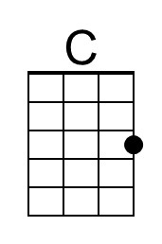 | 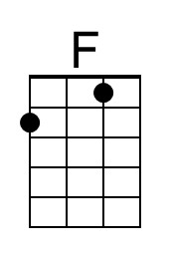
 | 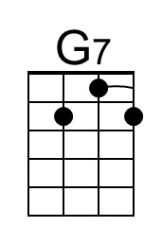 | 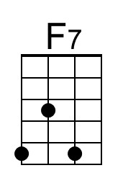
 | 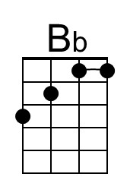
 | Baritone
 | 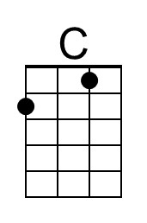 | 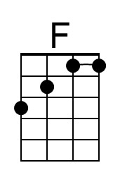
 | 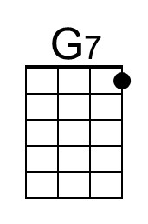 | 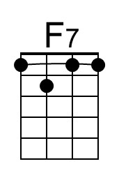
 | 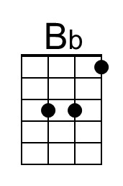


Mixed Nuts (Brock Walsh, 1994)
C47 G
Mixed Nuts by Dr. John (Mac Rebennack) from the 1994 movie “Mixed Nuts”

Intro Strum in on G  G C G C  Christmas Eve, I’m waiting, Saint Nick I ain’t baiting  C7 G  This year, no slackin’ your case, I’m cracking  D7  Them milk and cookies ain’t caught you yet  C F  Got a little something special by the TV set  Chorus  G C G C  Good news, hey Santa, Cashews and pecans  G Tacet  Hooray and Hosanna! Santa can’t resist those – mixed nuts  G7  Chick peas, hickories, chestnuts, Chinese  D7  Pine nuts, peanuts and pistachios  G C G C  No nog, no turkey, just beer, nuts and beef jerky  C7 G  Taste good, so salty, with somethin’ cold and malty  D7  All the fellas at work say I’m outta my mind  C F  But if I stay awake, I’m gonna getcha this time. Chorus  G7  Acorns, almonds, Barcelonas, Amazons,  D7  Black top, Indians, giant macadamias  G C G C  I wait up, kinda dimly, See a boot scootin’ up the chimney  C7 G  Jump up and try to pull it, Disappears faster than a bullet  D7  Six empty jars layin’ on the floor,  C F  Next Christmas he’s giving ten times more. Chorus (2x) | 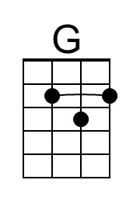
 | 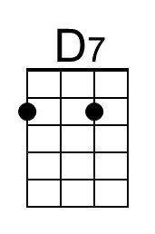 | 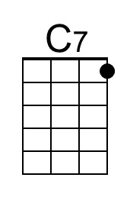
 | Baritone
 | 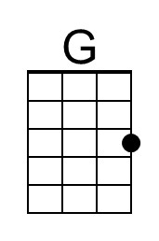
 | 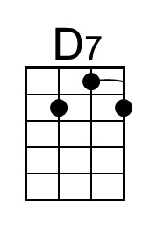 | 