Monster Mash (Bobby Pickett and Leonard L. Capizzi) (C)
Monster Mash by Bobby ‘Boris’ Pickett and The Crypt Kickers (1962)

Intro: Instrumental Chorus.  C Am  I was working in the lab late one night, when my eyes beheld an eerie sight.  F G  For my Monster from the slab began to rise, and suddenly, to my surprise.  C  (He did the Mash), He did the Monster Mash.  Am  (The Monster Mash), It was a graveyard smash.  F  (He did the Mash), It caught on in a flash.  G  (He did the Mash), He did the Monster Mash.  C Am  From my laboratory in the Castle East, to the Master Bedroom where the  vampires feast,  F G  The ghouls all came from their humble abode, to get a jolt from my electrode.  C  (They did the Mash), They did the Monster Mash.  Am  (The monster Mash), It was a graveyard smash.  F  (They did the Mash), They caught on in a flash.  G  (They did the Mash), They did the Monster Mash.  Bridge  F  The Zombies were having fun, (In-a-shoop, wha-ooo)  G  The party had just begun, (In-a-shoop, wha-ooo)  F  The guests included Wolf Man, (In-a-shoop, wha-ooo)  G  Dracula and his son.  Starting at the 2nd verse & the Bridge, the Crypt Kickers softly sing “wah-ooo” at the beginning of the first, second and fourth lines of the verse, while “Boris” comes in on the second beat of the line. At the beginning of the third line, they sing “wah wah-ooo.” | 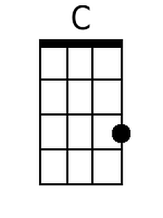  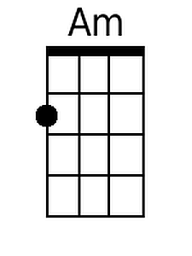  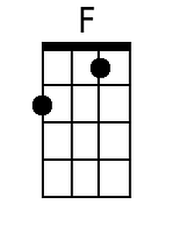  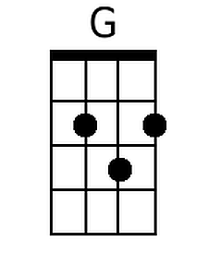  Bari  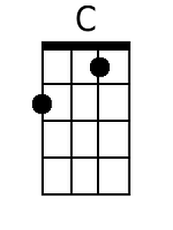  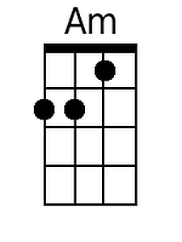  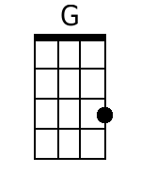  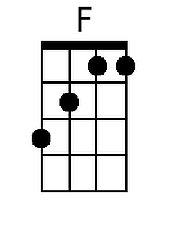  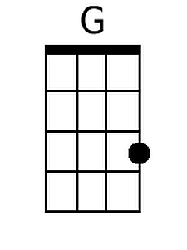

Monster Mash (C) – Page 2

C Am
The scene was rocking all were digging the sound, Igor on chains backed by His Baying Hounds.
F G
The Coffin Bangers were about to arrive, with their vocal group, the Crypt Kicker Five.

C
(They played the Mash), They played the Monster Mash.
Am
(The Monster Mash), It was a graveyard smash.
F
(They played the Mash), They caught on in a flash.
G
(They played the Mash), They played the Monster Mash.

C Am
Out from his coffin Drac's voice did ring, it seems he was troubled 'by just one thing.
F G
Opened the lid and shook his fist, and said, "Whatever happened to my Transylvania Tvist?

C
(It's now the Mash), It's now the Monster Mash.
Am
(The monster Mash), And it's a graveyard smash.
F
(It's now the Mash), It's caught on in a flash.
G
(It's now the Mash), It's now the Monster Mash.

C Am
Now everything's cool, Drac's a part of the band, and my Monster Mash, it's the hit of the land.
F G
For you, the living, this Mash was meant, too; when you get to my door, tell them Boris sent you.

C
(And you can Mash), and you can Monster Mash.
Am
(The monster Mash), And do my graveyard smash.
F
(And you can Mash), You'll catch on in a flash.
G
(Then you can Mash), Then you can Monster Mash.

Outro:
One instrumental verse with “Wah-ooo … Monster Mash,” at the beginning of each line. End with:
Cv Cv C
“wah wah-ooo.”
Monster Mash (Bobby Pickett and Leonard L. Capizzi) (G)
Monster Mash by Bobby ‘Boris’ Pickett and The Crypt Kickers (1962)

Intro: Instrumental First Verse.  G Em  I was working in the lab late one night, when my eyes beheld an eerie sight.  C D  For my monster from the slab began to rise, and suddenly, to my surprise.  G  (He did the Mash), He did the Monster Mash.  Em  (The Monster Mash), It was a graveyard smash.  C  (He did the Mash), It caught on in a flash.  D  (He did the Mash), He did the Monster Mash.  G Em  From my laboratory in the Castle East, to the Master Bedroom where the vampires  feast,  C D  The ghouls all came from their humble abode, to get a jolt from my electrode.  G  (They did the Mash), They did the Monster Mash.  Em  (The Monster Mash), It was a graveyard smash.  C  (They did the Mash), They caught on in a flash.  D  (They did the Mash), They did the Monster Mash.  Bridge  C  The Zombies were having fun, (In-a-shoop, wha-ooo)  D  The party had just begun, (In-a-shoop, wha-ooo)  C  The guests included Wolf Man, (In-a-shoop, wha-ooo)  D  Dracula and his son.  Starting at the 2nd verse & the Bridge, the Crypt Kickers softly sing “wah-ooo” at the beginning of the first, second and fourth lines of the verse, while “Boris” comes in on the second beat of the line. At the beginning of the third line, they sing “wah wah-ooo.” | 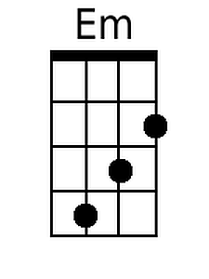  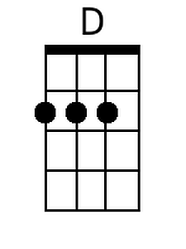  Bari  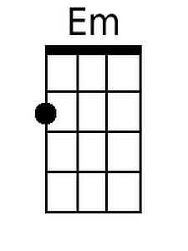  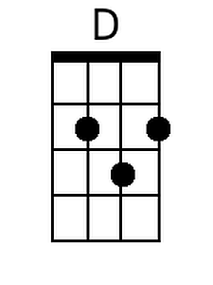

Monster Mash (G) – Page 2

G Em
The scene was rocking all were digging the sound, Igor on chains backed by His Baying Hounds.
C D
The Coffin Bangers were about to arrive, with their vocal group, the Crypt Kicker Five.

G
(They played the Mash), They played the Monster Mash.
Em
(The Monster Mash), It was a graveyard smash.
C
(They played the Mash), They caught on in a flash.
D
(They played the Mash), They played the Monster Mash.

G Em
Out from his coffin Drac's voice did ring, it seems he was troubled 'by just one thing.
C D
Opened the lid and shook his fist, and said, "Whatever happened to my Transylvania Tvist?"

G
(It's now the Mash), It's now the Monster Mash.
Em
(The monster Mash), And it's a graveyard smash.
C
(It's now the Mash), It's caught on in a flash.
D
(It's now the Mash), It's now the Monster Mash.

G Em
Now everything's cool, Drac's a part of the band, and my Monster Mash, it's the hit of the land.
C D
For you, the living, this Mash was meant, too. when you get to my door, tell them Boris sent you.

G
(And you can Mash), and you can Monster Mash.
Em
(The monster Mash), And do my graveyard smash.
C
(And you can Mash), You'll catch on in a flash.
D
(Then you can Mash), Then you can Monster Mash.

Outro:
One instrumental verse with “Wah-ooo … Monster Mash,” at the beginning of each line. End with:
Gv Gv G
“wah wah-ooo.”

