100 Year Old Moon Medley (songs published between 1908 and 1912)
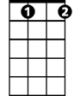
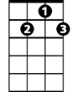
(1912)
C#dim
G7
Intro: G7 C#dim G7 C F7 C
As we sang love’s old sweet song on Moonlight Bay)
Cdim C Dm C Cdim C
We were sailing along on Moonlight Bay,
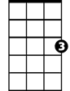
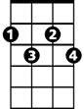
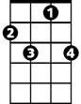
C#dim G7 C C#dim G7
C
Cdim
F7
You could hear the voices ringing – They seemed to say,
C F C Dm C Cdim C
“You have stolen my heart, now don’t go ‘way”
G7 C#dim G7 C F7 C
As we sang Love’s Old Sweet Song on Moonlight Bay
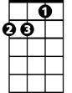
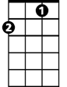
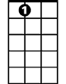
(1908)
Dm
F
A7
C G7 C - or- (Tabs) C string 0, 2 E string 0
Oh, won’t you
A7 D7 D
Shine on, shine on harvest moon up in the sky
G7 C Cdim F C
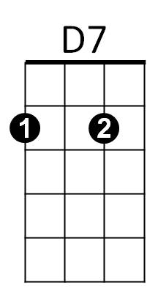
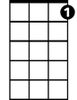
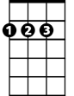
I ain’t had no lovin’ since January, February, June or July
C7
D
A7 D7 D
Snow time ain’t no time to stay outdoors and spoon
G7 C F7 C
So shine on, shine on, harvest moon for me and my gal
(1909)
C Cdim C
BARITONE
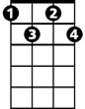
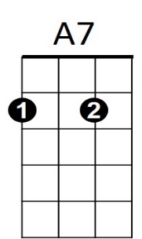
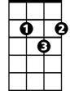
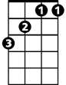
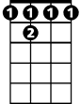
By the light (not the dark but the light)
G7
C
C7
Cdim
D
D7
C#dim
F
F7
C7 F A7 D7
Of the silvery moon, (not the sun but the moon)
G7 C#dim G7
I wanna spoon,(not knife, but spoon)
C C#dim G7
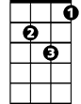
To my honey, I’ll croon love’s tune
Dm
C Cdim C
Honey moon,(not the sun but the moon)
C7 F A7 Dm
Keep a-shinin’ in June (not July but June)
C / Dm / C /
Your silvery beams will bring love’s dreams,
Am D7 G7 C F7 C tremelo
We’ll be cuddlin’ soon - By the silvery moon.

